Moorside Primary School

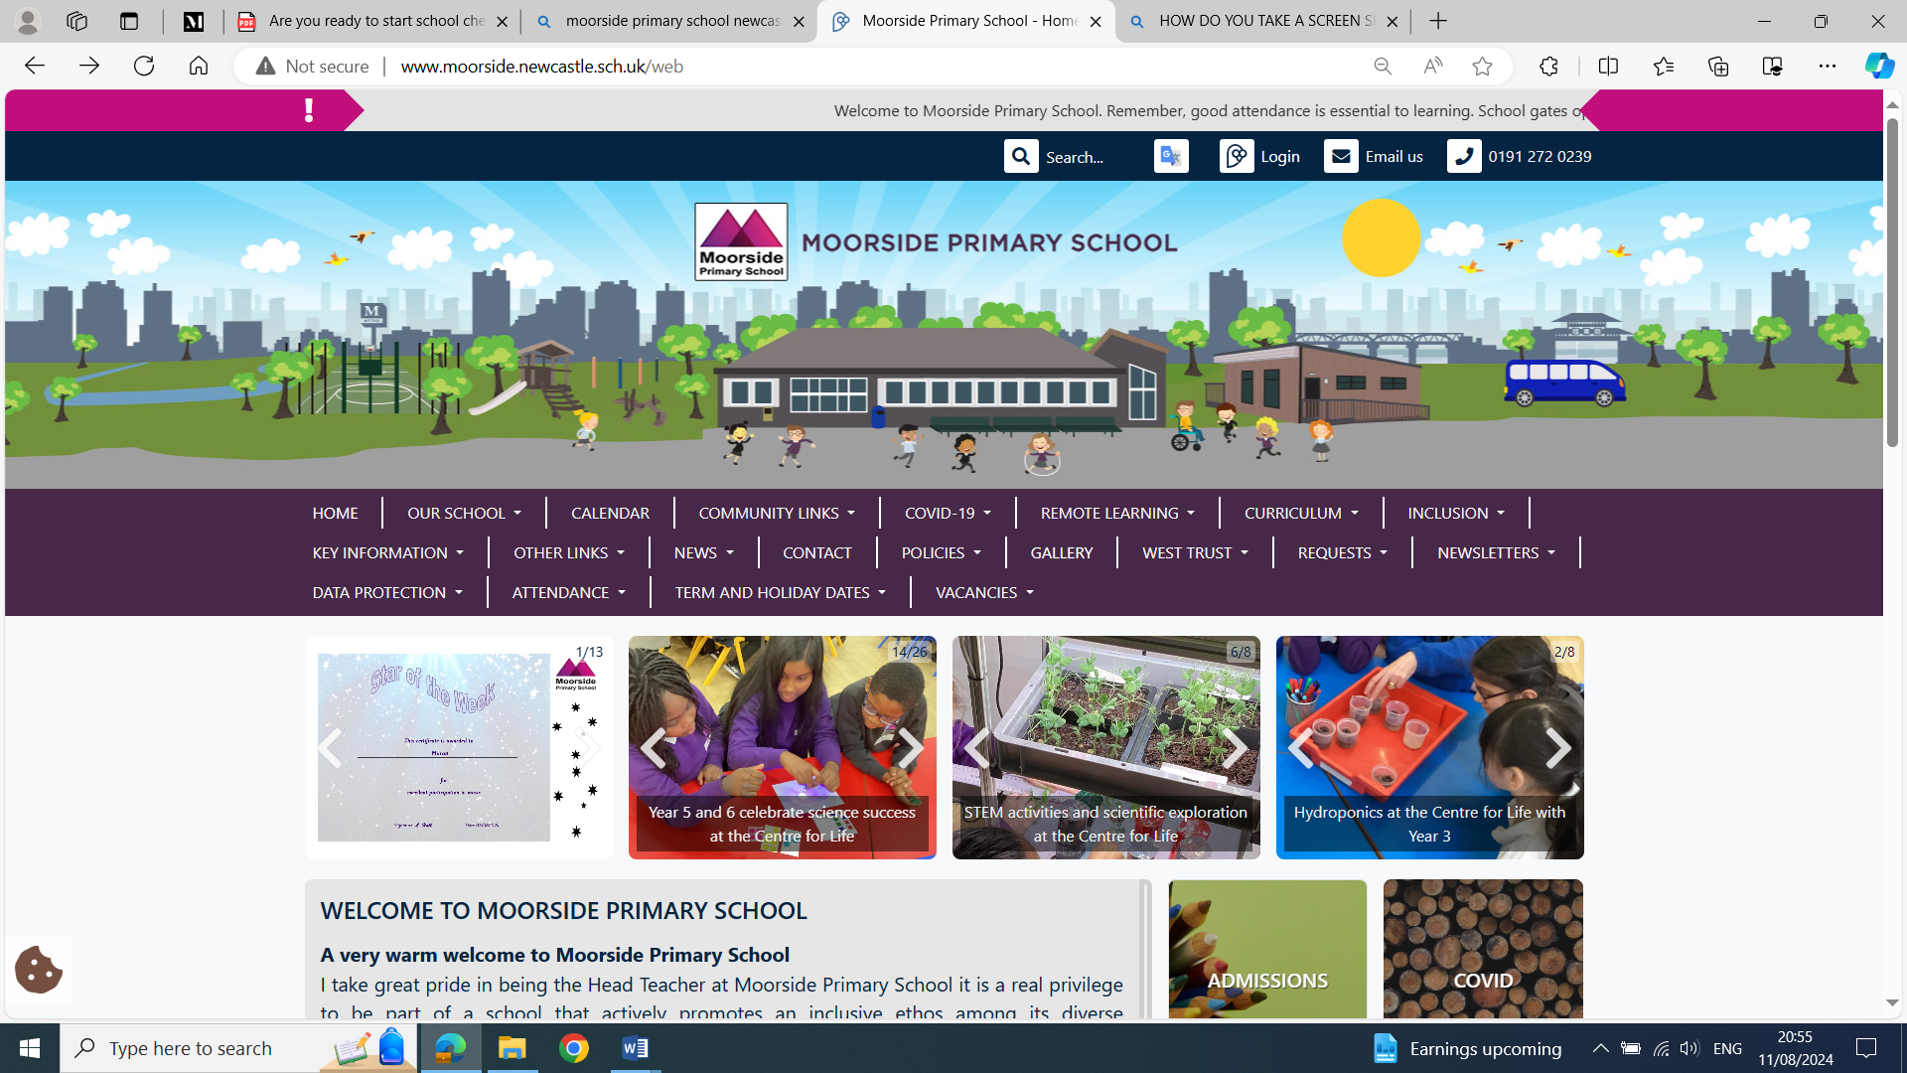

Welcome to the Early
Years Foundation Stage

Early Years Foundation Stage Information
Welcome to the Early Years Foundation Stage at Moorside Primary School. We are delighted that you have chosen to send your child to our school. We look forward to supporting you and your child on their learning journey with us. Please read this booklet carefully and keep it to refer to during your child’s time in Nursery and Reception.

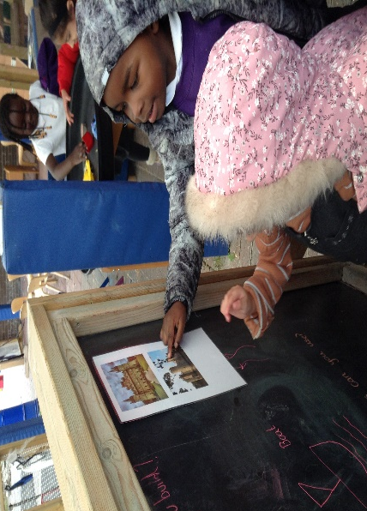

We are committed to working together with you to ensure that your child has a happy and successful experience during their time in Nursery and Reception. We know that children learn best when Parents/Carers and staff work together to encourage and support children’s learning so it is our priority to build a team around the child so that we can give them the very best start.

We very much look forward to getting to know you and your child, we are always available to answer any questions you may have.

Nursery
We are a twenty-six-place Nursery Class offering fifteen (15) hours a week over three days unless you are eligible for the Government child care thirty-hour offer.
The fifteen-hour placements are in two groups either full days Monday and Tuesday (8.45 – 3.05) and half day Wednesday morning (8.45 – 11.20 am). Alternatively, your child could attend half day Wednesday afternoon (12.20 – 3.05 pm) and two full days Thursday and Friday (8.45 – 3.05).

To determine if you meet the Government criteria for thirty (30) hours of free child care, you must apply online at https://www.gov.uk/30-hours-free-childcare. If you are eligible, you will receive a code to pass on to school.

We try hard to ensure Parents/Carers get the sessions they request for their child as much as possible. However, this is not always possible. We have a range of experienced staff to support your child in the Nursery, including additional staff across the Nursery and Reception. Throughout the day children will experience a range of learning experiences. This will include times of adult-led and directed learning as well as times where there will be free-flow learning. The free flow will be child-initiated and build on children’s interest and their inquisitive and development skills.

Settling in
We want your child’s start at the Nursery to be happy and secure. Starting Nursery is a very big step for many children, especially if they have not attended a Nursery or childcare setting previously, so we make the transition from home to school a gradual one, to help the children settle.

For your child to settle well and be happy, we will gradually extend the length of their stay. The decision to stay for the whole session will be made on an individual basis, by the staff, in consultation with you. We aim for your child to stay until 11.00 am for their first sessions, and until 1.00 pm when they will experience lunchtime in our school hall. After that, we extend their day, if they are happy and settled. Some children take longer than others to settle so we will extend the settling-in period if needed for individual children.

Once settled, the children will be expected to be in class before the gates close at 9.05 am and Reception children should be collected at 3.10 pm. Please note, the rest of the school from Year One to Year Six end of the day will be at 3.15 pm allowing Parents/Carers of children in EYFS time to collect their younger children first before making way to the main school yard to collect any older children.

On the first day, you may stay with your child and explore the Nursery together. Staff will come and play alongside you and your child and introduce other children to them. This will help them to become more confident to be in the classroom. We aim to support your child to happily separate from you every day. Each child is different and we will work with you to decide what is best for your child to support them in settling.

Reception
We have two Reception classes and we share an outdoor area with Nursery, much of which is sheltered, so the children can have “free flow” access to high-quality learning provision both inside and outside.

Across the two classes, we have two teachers, a Higher Level Teaching Assistant and two support Assistants, in addition, we have additional support staff who are shared across the Foundation Stage. Throughout the day children will experience a range of learning experiences. This will include times of adult-led and directed learning as well as times where there will be free flow learning. The free flow will be child-initiated and build on children’s interest and their inquisitive and development skills.

Starting school can be unsettling for children after the holidays especially if they have not had the experience of attending Nursery. However, the majority of children will be familiar with our Early Years either through being in our Nursery or from our transition experiences in the summer term. During the first week, we will support you in settling your child into Reception and getting to know each other to ensure that all children have a positive start to school.

Lunchtime is often the most difficult time for children when they start school, so do not be surprised if they come home very tired after lunch, even if they have been attending an extended day in preschool or Nursery.

If you have any concerns about how your child is settling or you feel that they may need to attend part-time for longer please speak to us and we will discuss what will be best for your child to help support their transition to Reception. The staff may feel that a longer transition period is necessary for some children, in which case we will discuss this with you.

Important Information
Starting school is a big step in your child’s life and we wish the settling-in process to be as smooth as possible. Please take the time to read this section of the booklet, as it will answer some of the questions you may have. If you have any further questions or queries, please do not hesitate to speak to us.

It is important that your child arrives at school promptly and ready to start the day. If your child is late, it can be very unsettling for them as the other children will be in the flow of their learning.

If you need to make arrangements for another adult to collect your child, you must let us know as we will not let them go with someone we do not know if you have not informed us.

What happens at lunchtime in the Early Years?
Your child may have a school lunch or bring a packed lunch to school. If they bring a packed lunch it should be clearly labelled with their name. Packed lunches should consist of healthy food with no nuts, fizzy drinks or sweets. Please note, that due to several allergies, we are a no-nut and no-kiwi school.

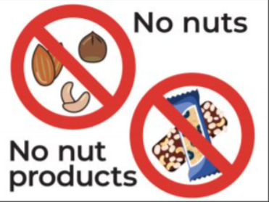

The children eat their meals in the hall and they are looked after by the staff and supported by the midday supervisors. Our school meals are all certified as halal.

Please note that children from Reception to Year Two receive universal free school meals. Nursery and children in Year Three to Year Six who are not entitled to free school meals due to income are asked to pay £1.00 for a school meal. This is because the Governing Body has agreed to subsidise the meals to support our families.

It is important that if your child has any allergies or needs a specific medication you make us aware of this as soon as possible.

What happens if my child is unwell at school?
Children who become ill during the school day are looked after by our qualified first aiders and if necessary, Parents/Carers will be contacted and asked to collect the child from school. We must have contact telephone numbers that we can contact you on during the school day. Please do not bring your child to school if they are feeling unwell.

What should I do if my child is unable to attend school?
Government regulations require Parents/Carers to explain every absence from school. If your child is absent or late, please telephone the school office to inform us.

If you wish to take your child out of school in term time, you will need to request a leave of absence in writing to the Head Teacher. This will only be permitted in exceptional circumstances and holidays are not authorised during term time. It is expected that all children in EYFS attend school every day and in Nursery every session.

We will follow up on any unauthorised absences including for children who are under five. If a child has 10 (5 Days) unauthorised absences within a ten-week period Parents/Carers are at risk of legal action. We must establish good routines in attendance from an early age.
In Nursery, if your child is continually absent then you are at risk of losing their Nursery place.

If your child has an appointment within the school day you will need to request the time for this on the morning of the appointment, so we can have your child ready. If you have other children in school, then that is your responsibility to have alternative arrangements for them to be picked up at their usual finishing time.

Family Learning and workshops
We believe in working together with Parents/Carers to support the children’s learning. We run regular sessions in Nursery and Reception for Parents/Carers to attend along with their children for some of the sessions; this is an effective way for us to share what we are teaching and how we teach it so that parents will know how to support us at home. This enables us to work together to help the children to make the best progress possible.

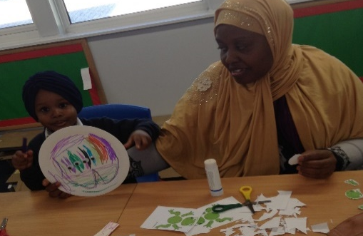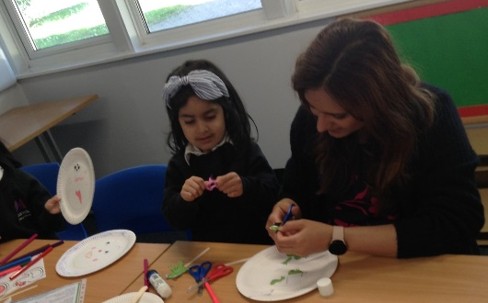

We believe that Parents/Carers are a child’s most important teacher so we are keen to work together to ensure that your child has the very best start at school. These are fun and practical sessions for you and your child, our sessions cover a wide range of skills from counting to phonics and reading. We will look forward to seeing you at our workshops!

Home School Reading
We want the children to develop a love of books and enjoy stories both at home and at school. All children will receive a free book bag.

In the Nursery, Parents/Carers can choose a book with their children to take home each day. In Reception, we will send home a book selected by your child for you to share with them. Please note this may be a book that the child cannot read, though they are keen to explore it. In addition, your child will bring home a Guided Reading book. This is a book that your child will have shared in class with a member of staff, and it is used to teach key reading skills. The book may have no words, and the children need to develop an ability to retell stories or gather information from illustrations, without having to read the words.

The expectation is that your child reads it by themselves with encouragement from you. Developing a love of books and reading is very important in a young child’s life so we will work very closely with you to support your child to enable them to develop into confident readers.

Throughout the year, we run sessions for Parents/Carers on how to support your child as they learn to read. If you have any queries or concerns about how you can support your child’s reading please speak to us. Children in Reception also have the opportunity to visit the school library where they will have the opportunity to choose a book. Please look after the books as they are important to children learning and they can be expensive to replace. If any books are damaged they will need to be paid for.

Are toys allowed at school?
Children are not allowed to bring toys of any kind to school, as this can often cause distress for your child if lost or another child tries to play with them.

Drinking Water
At Moorside Primary we believe it is important that children have free access to water which is readily available in the classrooms. Children in Reception will be provided with their own water bottle which we will regularly clean and refill.

Fruit and Milk
We provide a piece of fruit and a drink of milk each day for all the children who want it across Nursery and Reception. This helps the children to stop feeling hungry throughout the morning and is also an important social friendship, building time for the children.

Will my child have homework?
Each child will receive a free book bag when they start school. They will bring home books for you to read with them and a home/school reading diary. The staff will write comments, and there is an opportunity for you to reply with comments about your child’s reading.

In Reception, children will occasionally bring home a learning activity to reinforce the learning focus.

School Uniform
Children are not expected to wear uniform in the Nursery, though we do request that they come to school in clothes that allow them to move freely, and safe shoes so that they can take part in the physical play that is so important. Please make sure no jewellery is worn including earrings as children need to be safe to climb and move around.

Children in the Nursery are developing their independence with toileting, so please make sure that they wear clothes that they can manage by themselves. It is important that children are toilet-trained as they enter our Early Years, however, we know some children take longer than others with this stage of development, and we are happy to support you with this as soon as possible. We also have access to a school nurse who can support this process. If your child has an accident when in school and needs to be changed, we would ask that the clothes be cleaned and returned to us as soon as possible.

Staff help children to learn to manage their own clothes, though we want the children to become independent in this. We encourage creative exploration, so children will frequently be using paint and water in their play. We do provide protective aprons, and we help children to become independent at putting them on themselves. Sometimes children do get paint on clothing despite the provision of aprons so please be aware that your child should save their best clothes for the weekends.

In Reception, the children wear the school uniform which consists of a black or grey skirt or trousers, a white shirt or polo shirt, safe shoes and the school sweatshirt which can be purchased from the school office for £10.00.

The children in Reception and Nursery have free access to an outdoor classroom at various points in the day. It is therefore necessary to ensure that they are dressed appropriately. We ask that your children wear a waterproof coat to school in wet weather and protective clothing from the sun in the summer months, particularly a sun hat.

Physical Education
In Reception, your child will receive a free P.E. kit and bag, in the spring term, they will then need these in school weekly.

Sharing Achievement
Your child will have their own “Special Portfolio Book” which is a record of their learning and will contain photos of your child, written observations, pictures and “mark making” by your child. It will be available for you and your child to see regularly and in addition, we will offer you appointments where we can meet and discuss your child’s progress at various points in the year. You will receive a written progress report at the end of the summer term and we are always happy to discuss any aspect of your child’s learning and development.

Assessment for Learning
We know that Assessment for Learning (AfL) is a good thing. Also known as ‘formative assessment’, and good use of AfL sees it embedded into our day-to-day practice in the form of regular, informal assessments and observations. These observations are then used by staff to assess children’s understanding and their interests, and helps inform future planning to enable staff to deliver high-quality learning for all children. Effective assessment relies on staff understanding child development, and children can be best supported and educated to achieve their very best. It helps staff to provide purposeful play and learning experiences to support children to develop skills and knowledge whilst having fun learning.

There are three EYFS (Early Years Foundation Stage) statutory assessment points:

Progress check at two years – often completed by the health team

Reception Baseline Assessment (RBA)

Early Years Foundation Stage Profile (EYFSP)

In addition to ongoing observations and assessments, we find that summative assessments or a more specific assessment can be useful, though we use them with caution with young children and often for a specific reason:
- To clarify a concern a professional of Parent/Carer might have.
- To recognise and respond to the needs of each unique child.
- To celebrate a child’s strength and show progress.
- To provide a strategic overview and support a specific area of need.

Aims and Objectives
At Moorside Primary School, we believe that every child must be nurtured, valued and empowered to have the highest aspirations for their future and to reach their full potential through the provision of a stimulating, innovative, and creative curriculum. We strive for our learning community to achieve the highest possible standards by equipping them with the skills to succeed and inspiring a lifelong love of learning.

We are working together to:
- Continue to raise standards across the school, striving towards excellence
- Have high expectations of all our learners
- Develop our children’s sense of purpose, understanding, motivation and ability to ask and answer questions objectively
- Maintain a team of staff who are valued and work well together
- Continue to develop a school ethos of calmness and purposeful activity
- Develop the physical environment in which we all work and play
- Encourage strong school/home links
- Inspire our community to value education and its benefits
- Acknowledge our common values whilst embracing our differences

Our School Values
We all believe...
- Our local community deserves a school they can be proud of
- We are a caring community where everyone is welcome
- We all value, respect and support each other
- Our community has the right to be safe and healthy.
- Our children should have the chance to enjoy and be enthused by their time in our school

School Expectations
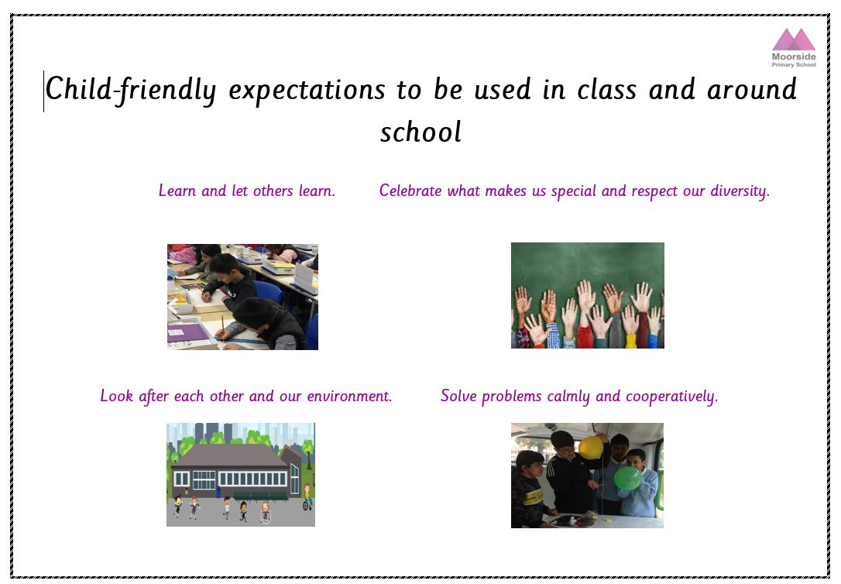

The Foundation Stage Curriculum
The Nursery and Reception curriculum is based on the Early Years Foundation Stage Curriculum Framework. These are Government guidelines for what each child should be able to do by the end of Reception. Both Nursery and Reception classes use this framework to plan high-quality learning experiences.

All of the learning experiences we offer at the Foundation Stage are through play. It is through play that young children learn to make sense of the world around them, to formulate ideas, and to build relationships with others. They are encouraged to choose their activities, both indoors and outdoors. Children are encouraged to ‘have a go’ at all activities and areas of play and most importantly, to have fun! Staff plan, focused activities for your children each day, which are supported by adults. We make regular observations of the children and use these to plan activities to develop their skills, based on the children’s interests and what they can and like to do.

The Seven Areas of Learning and Development

The EYFS framework is a crucial tool for supporting children with their learning and development from birth to five years old. At the core of the EYFS are the seven areas of learning that encompass knowledge, skills and experiences children need to develop.

Personal, Social and Emotional Development
For children to be successful in all areas of learning, they need to feel secure and develop a positive sense of themselves. Much of our provision is based on the need to provide opportunities for personal, social and emotional development.
Children will:
- Respect themselves and others and develop a positive self-image
- Take turns and share
- Feel confident to take risks and cope with mistakes
- Make friends and cooperate in a group
- Develop a positive attitude to learning
- Understand and embrace differences in gender, special needs, ethnicity, religion and cultures.

Communication and Language
This area of learning includes non-verbal communication, speaking, listening, and expressing oneself effectively. Our classrooms provide many opportunities for the children’s development in this area. We use role-play, book corners, a listening area, plus a wide range of other purposeful activities and interventions to enable children to practice and develop their skills.
Children will:
- Develop the use of appropriate language in many different activities and every part of the curriculum
- Retell and talk about texts with confidence
- Listen to a range of stories and make relevant comments or ask questions
- Answer questions about their play
- Express themselves and develop their ideas.

Physical Development
In the Foundation Stage, Physical Development is vital in helping children to develop a positive sense of well-being. Children learn to improve their coordination, control, manipulation and movement. Children learn through being active and their physical development takes place through other areas of learning.
Children will:
- Experiment with actions using small and large apparatus
- Use different resources in different situations
- Practice large and small movements both inside and outside, such as climbing and jumping and writing
- Develop their skills using small apparatus and playing games
- Discuss the importance of good health and how we can be healthy at home and school.
- Respond with movement to different stimuli, such as music, stories and rhymes.

Literacy
Children will have opportunities to listen to, retell and read a wide range of texts. They will write for many different purposes across many different areas. Children will link sounds to letters and use their phonic knowledge to write, giving meaning to their mark-making.
Children will:
- Share and read a range of quality books with adults and each other and learn how text works
- Retell and talk about texts with confidence
- Learn that words have meaning and develop knowledge of letter sounds
- Know there are different scripts
- Communicate their ideas confidently through drawing, mark-making and writing

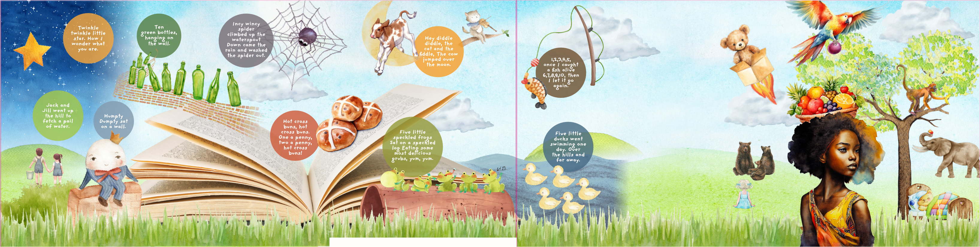

Mathematics
This area of learning involves counting, sorting, matching, recognising patterns, working with money, identifying shapes and measuring.

We develop children’s mathematical understanding through play, songs, stories and rhymes as well as investigative and problem-solving activities.

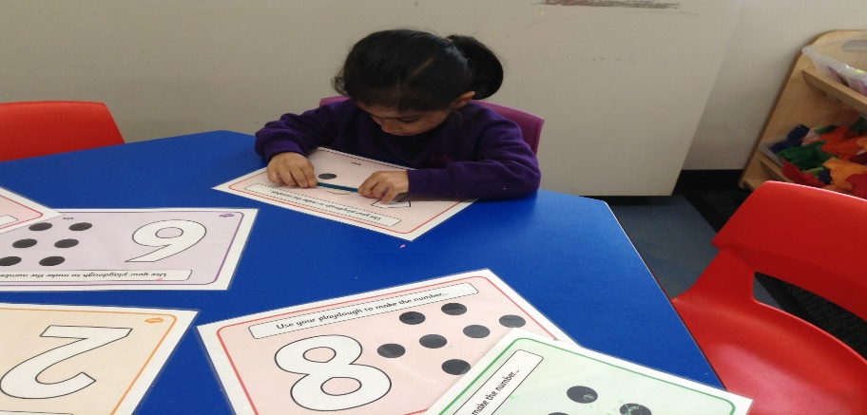

At Moorside Primary School we are committed to a practical approach to the learning and teaching of mathematics. We believe that children will develop a firmer understanding of mathematical concepts if they are provided with a range of practical experiences which allow them to practise and develop their skills.
Children will:
- Use and recognise numbers
- Count and order numbers
- Develop an understanding of more and less
- Make simple calculations
- Create and follow patterns
- Become aware of, recognise and name simple shapes within the environment
- Understand and compare measures and learn about measuring time.

Understanding of the World
In this area, we help children to develop the knowledge skills and understanding to help them make sense of the world. It is the foundation for later work in science, design and technology, history, Information Technology (IT), geography and Religious Education (RE).

We give children opportunities to find out about the world around them and to ask questions. They design and make different objects using a wide range of tools and materials. We enable children to find out about the past and learn about the school and where they live. They become aware of differences in gender, ethnicity, culture, language and religion. Children select and use technology for different purposes.
Children will:
- Develop their skills to use and explore a variety of tools and materials
- Investigate how things work
- Learn about living and non-living things
- Measure, join, cut, select and combine materials
- Have opportunities for exploration, observation, problem-solving, prediction, critical thinking, decision making and discussion.
- Use technology for a variety of different purposes where appropriate.

Expressive Arts and Design
This area of learning includes art, music, dance, role-play and imaginative play. Throughout the Foundation Stage, children need many and varied opportunities to develop creatively. It is an important area of the curriculum, as being creative enables children to make connections between one area of learning and another.
Children will:
- Express their creativity and originality through music, art and imaginative play
- Develop an appreciation of art and music from different cultures
- Experiment and work with a range of different techniques and materials to express their ideas
- Explore making sounds with their bodies and with instruments
- Talk about their work and develop confidence to express their ideas
- Respond with movement to music and songs.

We hope that the information included in this booklet has helped you to understand how we will be working together to give your child the best possible education and to let you know how you can help at home. Please do not hesitate to come and speak to us if you have any questions.

Reminders:
School gates open at 8.45 am
School gates close at 9.05 am

School gates open at end of day:
Nursery – end of day time 3.05 pm
Reception at 3.10 pm
Main School – Year One to Year Six 3.15 pm

Lunch times for Nursery (if Parents/Carers wish to take home) 11.20 am – 12.05 pm
Lunch times for Reception (if Parents/Carers wish to take home) 11.30 am–12.15 pm

Further Information

School contact number: 0191 272239
School email address: admin@moorside.newcastle.sch.uk
Head Teacher contact: linda.hall@moorside.newcastle.sch.uk
School website: http://www.moorside.newcastle.sch.uk/web/

