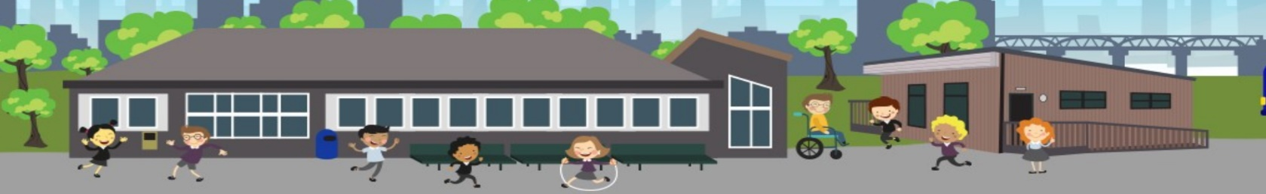

After School Clubs
Moorside Primary School
Newsletter
January 2020
Children from Years 4, 5 and 6 have been taking part in after-school clubs.

Board Games – Monopoly

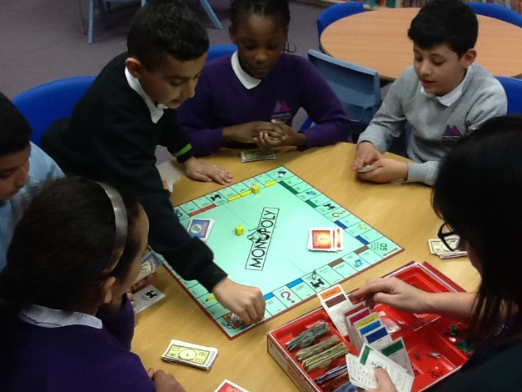
“It’s a really enjoyable game””
“It’s a really enjoyable game that everyone would like to join in”really enjoyable game that everyone would like to join in”

Board Games – Monopoly

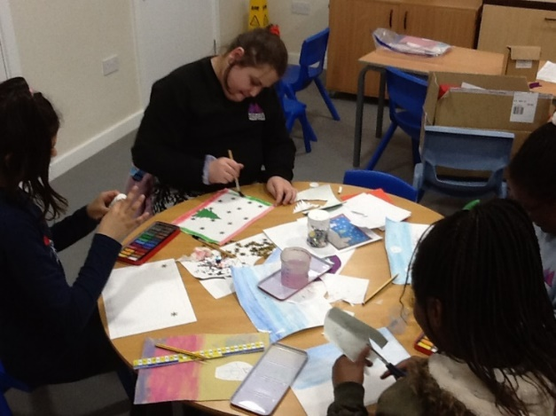
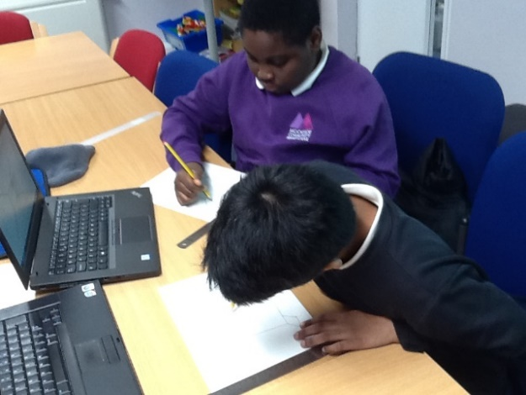
“I like being here and making things. We can give whatever we make to our families”
“It’s really fun here, we are doing posters and painting Winter scenes”really enjoyable game that everyone would like to join in”

“The best part of technical drawing is that we get to draw on paper and use the computer”really enjoyable game that everyone would like to join in”

“Technical drawing is lovely and really fun, we drew people and different shapes”
“Really fun”
“It’s really fun and fun to spend time with other people”
Arts and Crafts

Technical Drawing with ICT

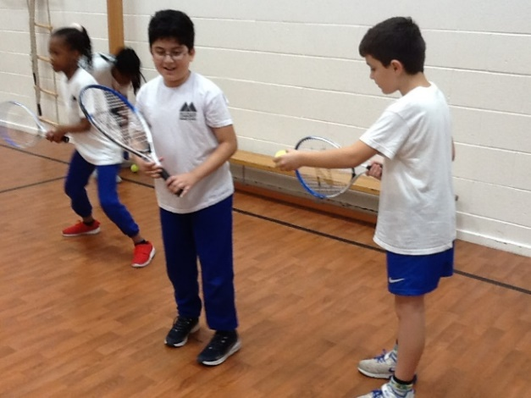
Multi-Skills

“It’s fun because we get to do different sports and while doing this we get to be fit”
“It’s really fun because we get to do different sports every week and we get to be fit”really enjoyable game that everyone would like to join in”

“I like playing different games”

Dates for your Diary

- Monday 17th February to Friday 21st February – School closed for Half Term.
- Monday 6th April to Friday 17th April – School closed for Easter.
- Friday 8th May – School closed for Early May Bank Holiday.

Stars of the Week
w/c 6th January 2020
Class | Name | Class | Name
Nursery | Samuel, Haris | 3B | Anthony
RK | Raman | 3L | Usman
RS | Aleena | 4C | Lucy
1CR | Maryam | 4LJ | Miroslav
1T | Mohammed Iesa | 5W | Israt
2H | Dani | 5RH | Jessica
2W | Amy | 6K | Fareeda
 |  | 6C | Nashita
 |  | 6D | Fatima

w/c 13th January 2020
Class | Name | Class | Name
Nursery | Walid, Khadeja | 3B | Ezra
RK | Christyn | 3L | Izma
RS | Camila | 4C | Sehar
1CR | Noor Fatima | 4LJ | Anisa
1T | Sarah | 5W | Sandra
2H | Ameerah | 5RH | MD Yasin
2W | Facundo | 6K | Andile
 |  | 6C | Sabina
 |  | 6D | Hanna

w/c 20th January 2020
Class | Name | Class | Name
Nursery | Amaan, Muhammad | 3B | Ibrahim
RK | Greatness | 3L | Serwer
RS | Israel | 4C | Muhammed Awais
1CR | Liam | 4LJ | Sara
1T | Jozef | 5W | Dimah
2H | Amelia | 5RH | Aboudeh
2W | Jibraeel | 6K | Jozef
 |  | 6C | Naomi
 |  | 6D | Gospel

w/c 27th January 2020
Class | Name | Class | Name
Nursery | Wendy, Grace | 3B | Cherish
RK | Jana | 3L | Fatimah
RS | Adiba | 4C | Syed
1CR | Chimdindu | 4LJ | Roshni
1T | Niga | 5W | Rumaisaa
2H | Hlaa | 5RH | Fatima
2W | Franklyn | 6K | Adella
 |  | 6C | Scarlet
 |  | 6D | Reemaz

w/c 3rd February 2020
Class | Name | Class | Name
Nursery | Ricky-Junior, Mayokun | 3B | Patrik
RK | Jason | 3L | Faith
RS | Nabi | 4C | Shoaib
1CR | Maryam | 4LJ | Iram
1T | Mosaver | 5W | Daniel
2H | Ibrahim | 5RH | Keenan
2W | Farah | 6K | Shabnam
 |  | 6C | Demi
 |  | 6D | Cyntia
Upcoming Events

UK Parliament Outreach
On the 7th February 2020, we will be having an “Introduction to the UK Parliament” Assembly for the children in Key Stage Two. This lively, interactive assembly will introduce students to what UK Parliament is and how it works. More importantly, they’ll learn what it means for their lives as citizens.
The children will learn:
- How does our democracy work?
- How can young people get involved in the work of UK Parliament?
- What are the roles of MPs and the House of Lords?
Prior to the visit, we will be exploring the UK Parliament and associated subjects such as Citizenship, Living in the Wider World and British Values, in our lessons.
There is a possibility that our local MP, Chi Onwurah, may be able to take part in this assembly which would be an added bonus.

Special Author Event

Thirty of our Year 5 and 6 pupils will be attending a special author event organised by Seven Stories (The National Centre for Children’s Books) on Tuesday 4th February.

Award-winning author Ross MacKenzie will be talking about his new book Evernight. This story is set in a world of witches and shadow-men with the hero, Larabelle Fox, hunting for treasures in the sewers of King’s Haven to survive.

Ross will talk pupils through his inspiration for the book, from the sewers of Victorian London to steampunk technology, and the creation of memorable villains. This will be a fun, inspirational event from a great speaker.

Focus on Reading
Reading is one of our key priorities in school this year so we would ask you to encourage your children to bring their book bags to school every day and take an interest in what they are reading, listening to them read as much as possible and helping to support us in enabling them to develop a real interest in reading for pleasure.

