To use division methods
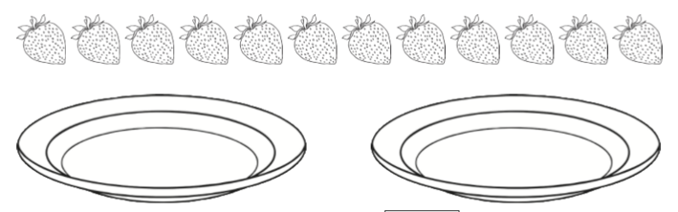
12 $÷$ 2 =

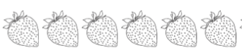
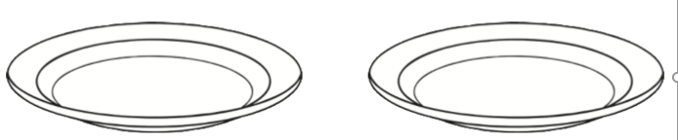
6 $÷$ 2 =
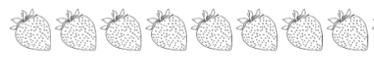

8 $÷$ 2 =

