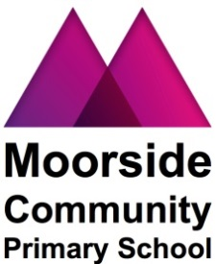

FOOD ALLERGIES

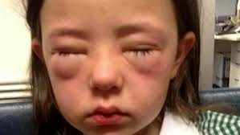

As you are aware, our school promotes healthy eating for our children. In addition, we have several children in school who have food allergies.

Please can we ask you, therefore, to ensure that your children DO NOT bring any nuts into school or any food containing nuts including sandwiches with Nutella chocolate spread.

Please note, the following contain nuts and therefore SHOULD NOT BE BROUGHT INTO SCHOOL.

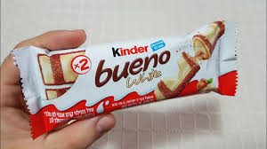
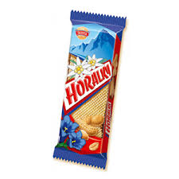

We also have a child who has had a severe allergic reaction to kiwi fruit. Therefore, we would like to kindly ask that you to ensure that your children do not bring any kiwi fruit in their packed lunches.

We have also made the decision that cakes, food or sweets will not be permitted in school to celebrate birthdays. Instead, we will find alternative ways of acknowledging your child’s birthday and making the day special for them.

