Year 2 (Wednesday 3.2.21)
Exercise: Stretch your arms across your head, one side at a time. Slowly tilt your head from side to side then forwards and back.
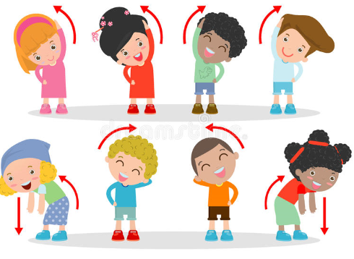
English
Learning intention: To write a witch story.

Use the PowerPoint and begin to think about changing the setting in the story to create your own version. Draw a story map showing the beginning, middle and end of the story. Remember to use your new setting.
Alternative 1: Use the PowerPoint then draw a story map using your own setting. Show the beginning, middle and end.
Alternative 2: Use the PowerPoint to remind yourself of the story. What happened in the beginning, middle and end of the story? Draw this on a story map.

Spelling: pass plant bath

Handwriting: practise ‘ea’ using the PowerPoint. Alternative 1: practise ‘ay’ using the PowerPoint. Alternative 2: practise ‘m’ using the PowerPoint.

Reading:
Grey and blue- Read the non-fiction text about Africa. Talk about it with an adult or make notes of new information you have found out.
Orange and yellow- Use the PowerPoint or select ‘A bad mood’ on OxfordOwl. Read this and discuss with an adult. Which part did you like best? Explain why.
Alternative:
Pink and purple- Apply your knowledge of the ‘igh’ sound. Read and identify the real and nonsense words on the sheet.
Red and green- Using the worksheet, practice reading the letter sounds. The read the words from our new story. An adult might need to read them first.

Maths
Learning intention: To use division methods.
Use the PowerPoint to learn about division as repeated subtraction using a blank number line. Complete the worksheet to divide using repeated subtraction on a blank numberline.
Alternative 1: Use the PowerPoint to learn about division as repeated subtraction using a number line. Complete the worksheet using the numberline as support.
Alternative 2: Use the PowerPoint to learn about division by sharing. Complete the worksheet using your knowledge. You could use objects around your home and divide by sharing.

Music: Listen to or read the PowerPoint about music in the 1960’s and 1970’s. Talk to an adult about what you have learnt.
Remember school website is:
http://www.moorside.newcastle.sch.uk/website If stuck or want to send completed work then email linda.hall@moorside.newcastle.sch.uk

