Moorside Primary School
Family Learning Newsletter
June 2019
Welcome to Moorside Primary School’s family learning newsletter
Family learning classes
We have had a range of family learning classes running throughout the school year. Our classes this year have been successful and it has been lovely to see so many parents also enjoying the classes.

Computing
We have had a computer course running since January 2019 which has been very popular. The course has covered basic I.T. skills as well as e-safety and has led to parents achieving a qualification. The parents that have attended have also been put forward to receive an award which is fantastic. Well done!

Phonics
This course is aimed primarily for children in Reception and Year 1. The course lasts five weeks and gives parents an understanding of how phonics is taught in the classroom. The children celebrate their parents’ success on the last session.
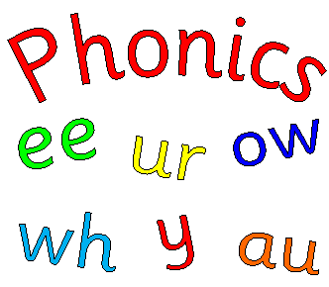
Family Language
This is an ongoing course for parents who do not have English as a first language. The course can help to improve English skills for everyday life, including making appointments, speaking with the teacher and social conversation.
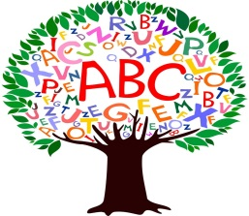
Arts and Crafts
We have recently just completed an arts and crafts course. Parents and children have enjoyed this course, working together to make various items, including a dream-catcher and lamps. There will be another arts and crafts course next year.
Story Sacks/Number Sacks
These courses run each year and are primarily aimed at EYFS and KS1. The course usually lasts five weeks. Parents work alongside the family learning tutor to create a story/number sack that they can use at home to help their children with their learning. The children also participate in the last session with their parent.
Ladies Fitness
This is a very popular session which is held each week on a Thursday morning 9.15 – 10.15 am in the school hall. We have had feedback from the ladies currently attending that this session is improving both their health and well-being. We are looking for this session to continue next academic year.

We are hoping to extend the session to include a coffee morning between 10.15 am. – 11.00 am.
Science Workshop
We had a science workshop at the beginning of the year which was open to all of Key Stage 2. This was a very popular course for both parents and children. The children took part in each session doing various experiments, often making models that they could take home with them.

There will be more science workshops next year due to its popularity and high demand for places.

Cancer Champions
This was a course to make parents aware of various cancers and the importance of seeking medical help as early as possible. It also helped the participants to be able to pass on the information to others confidently. The parents that attended this course were invited to the Centre for Life to be celebrated with other cancer champions from other schools.

We hope that you find this newsletter helpful and informative.

