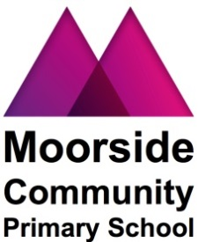
Moorside Community Primary School
Beaconsfield Street
Newcastle upon Tyne
NE4 5AW
Telephone: 0191 272 0239
Email: admin@moorside.newcastle.sch.uk
Website: www.moorside.newcastle.sch.uk

27th April 2018

Dear Parents/Carers,

Reminder - Year 3 School Meals

Just a reminder that in September, your child will be going into Year 3, when the government scheme regarding Free School Meals will no longer apply. Please read the attached form and if you think you may be entitled to free school meals for your child, please complete the form and return to the school office or apply online at www.newcastle.gov.uk/freeschoolmeals. If you don’t qualify for free school meals, you will need to pay £10 per week at the beginning of each week from September. Alternatively, your child can bring a healthy packed lunch to school, ensuring that it does not contain nuts, kiwi fruit or any products containing nuts including Nutella.

Yours Sincerely,
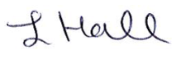

L. Hall
Head Teacher

Moorside Community Primary School
Beaconsfield Street
Newcastle upon Tyne
NE4 5AW
Telephone: 0191 272 0239
Email: admin@moorside.newcastle.sch.uk
Website: www.moorside.newcastle.sch.uk

27th April 2018

Dear Parents/Carers,

Reminder - Year 3 School Meals

Just a reminder that in September, your child will be going into Year 3, when the government scheme regarding Free School Meals will no longer apply. Please read the attached form and if you think you may be entitled to free school meals for your child, please complete the form and return to the school office or apply online at www.newcastle.gov.uk/freeschoolmeals. If you don’t qualify for free school meals, you will need to pay £10 per week at the beginning of each week from September. Alternatively, your child can bring a healthy packed lunch to school, ensuring that it does not contain nuts, kiwi fruit or any products containing nuts including Nutella.

Yours Sincerely,

L. Hall
Head Teacher

