Tuesday 20th March 2018
Dear Parents/Carers,

RE: Spring Assemblies

We would like to invite you to our Spring Assemblies taking place next week. In these assemblies, we will be sharing your children’s learning from this half term.

There will be two assemblies and the classes will be split as follows:
Tuesday 27th March 9:15am | Wednesday 28th March 9:15am
RC | RL
1C | 1CS
2A | 2J
3G | 3F
4W | 4P
5S | 5W
6B | 6R

Kind Regards

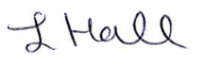

L. Hall
Head Teacher
Moorside Community Primary School

