Nursery and Playgroup Learning
(Week 08/02/2021)

Start of the day – Follow the exercises in the PowerPoint with someone in your family. Before starting everyone feel their heart – is it beating slowly?

When you are finished your exercises feel your heart beat again – you should be able to feel it beating much faster now.
Repeat these exercises each day.
Literacy – We are going to look at a new story today called – Bear on the Stair – with someone in your family listen to the first two slides then stop and talk about what you think will happen next.
Listen to the rest of the story – were you right? Talk about the story and try to retell it from the beginning and go back and listen to the story again to check if you were able to retell it in the correct order.
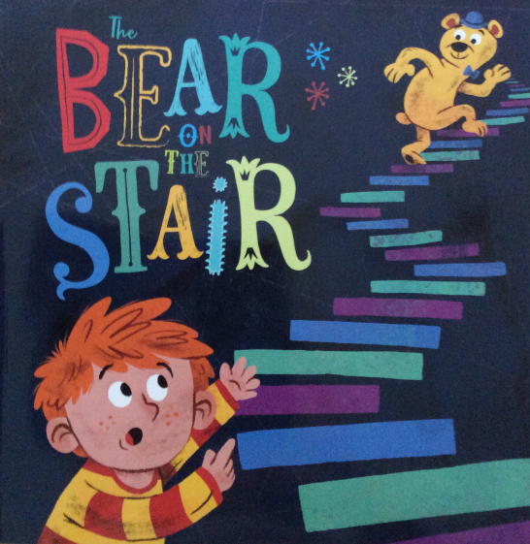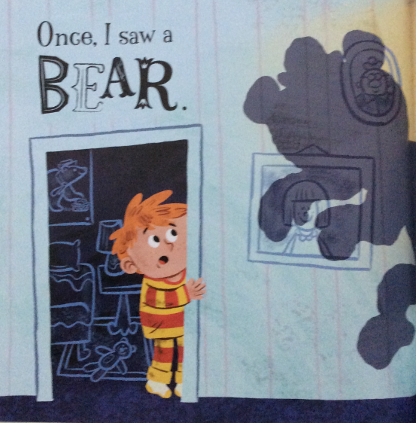

Handwriting pattern 1 – This is linked to our story trace over with your fingers first then with a pencil or pen.

Handwriting pattern 2 –Explore what you can see on in the pictures and where the patterns take you to. Once again trace over with your fingers first then with a pencil or pen.
Maths
- Sing Baa Baa Black Sheep using actions to help you with the rhyme it is on your Nursery Rhyme PowerPoint – can you find it?
- Explore the PowerPoint for number 2 and listen to it carefully. Then see if you can find 2 of different things such as two cups, two shoes, and two pens.
- Explore the numbers 0 – 5 going over the numbers with your fingers then with a pencil or pen and have a try at writing the numbers. When you have done this try to find objects for each number – so l spoon, 2 socks until you have collected 5 of something.
Songs and rhymes to learn:  - Revisit out Nursery Rhyme PowerPoint and join in with the different Nursery Rhymes try to sing each of them every day so you begin to sing them without any help.  - Try to put new actions into your rhymes as you sing them. | Remember the school website is:  http://www.moorside.newcastle.sch.uk/website  If you are stuck or want to send completed work then email  linda.hall@moorside.newcastle.sch.uk
Understanding of the world
Follow the PowerPoint exploring the woods and talk to someone in your family about what you see.

