Purple/pink
Read the text again and answer these questions.
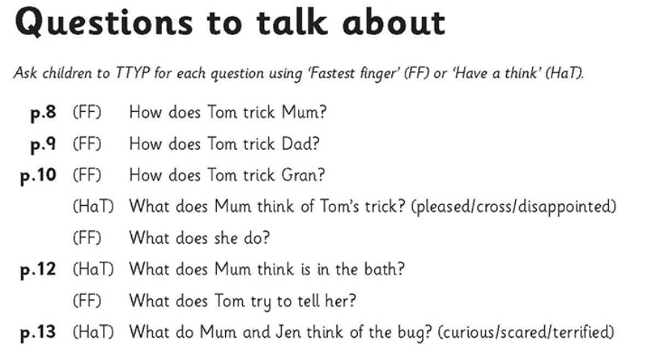

Did you like the story? Write one sentence telling a friend why they should (or shouldn’t ) read the story.

