Art Learning Intention: To learn about the designer Lucie Carrasco.

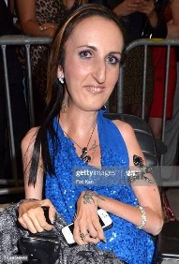
In the world of high fashion, Lucie Carrasco is the only designer with a disability to make it as far as she has. In 2011, at the Cannes Film Festival, she produced a feminine line bursting with amazing dresses.
Lucie, who is from Lyon (France), has been obsessed with beautiful women her entire life. Adopted by a glamorous mother, who instilled an appreciation of visual beauty in Lucie, designing women’s clothing was a natural progression for her.
Although Lucie had a long life interest in fashion, this was never something anyone had expected. Doctors predicted Lucie would only live until she was three years old. Born with spinal muscular atrophy (SMA), a condition that does get progressively worse, she has defied all expectations in an unbelievable way. She has written a book based on her personal mantra (belief) of staying strong.
In 2013, she focused on something big – a big move to the US; LA to be specific. This had been a lifelong dream of hers and she coupled it with a cross – country trip across the US – The Roll Forever Tour. On the tour, she drove her chair from NYC to LA, spending 4-5 hours each day on the road, as well as handing out digital tablets to children with disabilities in hospitals and rehabilitation units along the way. Ultimately, Lucie’s goal was to show the world we can reach for our dreams despite different circumstances.
Because of Cannes, Lucie has been fortunate enough to meet celebrities who have become fans of her design line. Lucie’s couture collection is truly something special. Super feminine, the clothes are designed to make a woman feel completely and utterly beautiful. The clothes are designed for able-bodied women. Adapted clothing isn’t something she is doing as of yet.
