Moorside Community Primary School
Newsletter
Newsletter

Fond Farewells

Mrs Gabbitus
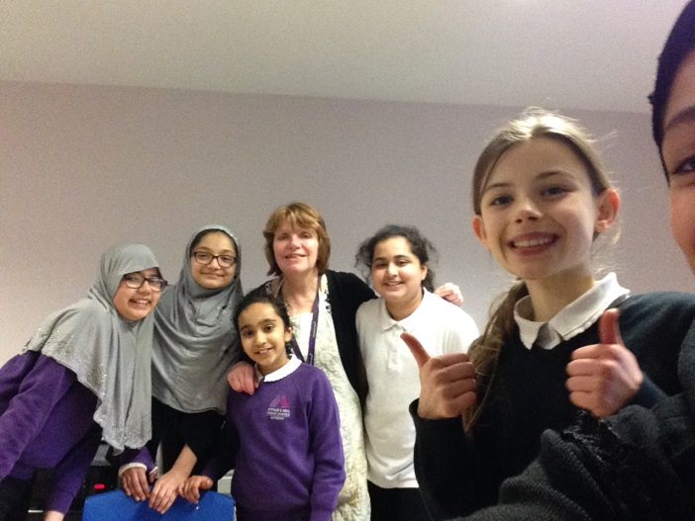
We would like to say goodbye to Mrs Gabbitus, our well-loved teaching assistant who has been working at Moorside for 18 years. She will be a big miss with staff and pupils alike. We wish her all the very best as she starts the next chapter in her life. She promises to come back on a regular basis to provide scones and St. Patrick’s Day buffets.
Mrs Graham
We would also like to say goodbye to Mrs Graham, another inspirational teaching assistant who has been working at Moorside since it opened 34 years ago. She has been a wonderful asset to the school and will be sadly missed, both for her teaching abilities and her poetry. She recently won the Jo Cox Poetry Prize with her poem ‘The Washing Machine’.

Miss Burns is also beginning her maternity leave and we wish her all the best in her new role as Mummy.
Finally, Miss Powell is moving on to pastures new and we wish her good luck for the future.

Visit to St. James’ Park

On Thursday 7th December, people from Year 5 and 6, who are Murray house users and school councillors (old and new), went on a trip to St. James’ Park. The purpose of this visit was to help rename the community centre, which has recently been taken over by Newcastle Foundation. However, to ensure that we had an idea of the stadium, we first had a tour of the grounds- led by a tour guide named Tom. He took us to the dressing rooms, where we saw the kits. we walked through the tunnel and sat on the highest seat in the stadium. We ended at a box where we were met by a man called Gav. He showed us the vision for Murray house and also the possible names for it. As a group we voted on the options, such as: Unity, The Park, The Point and more. As a school, we have been given the task of thinking of our own names for the modern building, which will be re-built by 2020.
The final four names that we have suggested as a school are:
- The United Stand
- Hi-Five
- The United Centre, and
- Unity House.
By Amber and Arshan, Year 6

Wishing you all a very merry Christmas and a Happy New Year! See you all back on the 8th Januray.

w/c 11th December 2017

Well done to 5S for achieving 99.3% attendance!

Stars of the Week!

w/c 18th December 2017
Attendance w/c 04/12/2017:

Class | Attendance
RC | 96.2%
RW | 91.6%
1C | 89.0%
1CS | 90.5%
1L | 84.5%
2A | 96.0%
2J | 92.7%
3G | 90.7%
3R | 92.7%
4L | 98.5%
4P | 93.8%
5S | 99.3%
5W | 91.8%
6B | 96.1%
6R | 94.4%
6W | 93.5%

Each week the teachers from Reception to Year 6 classes will select a child that they believe has worked really hard that week, has carried out something special or been exceptionally kind to someone. We will then share this in assembly on a Monday with others and present them with a certificate to acknowledge their hard work. Then throughout the rest of the week they will lead their class in and around school.

This week’s stars are:
- Dween Ibrahim (RC) for being a great friend.
- Amy Thomson (RW) for showing good sitting and listening on the carpet.
- Praise Alexander (1L) for beautiful handwriting and sentence work.
- Dhiraar Haque (1C) for greatly improved handwriting and fantastic sentences.
- Athulya Edirisingha (1CS) for great vocabulary and written work.
- Grace Hayes (2A) for brilliant subtraction of 2 digit numbers.
- Sulaiman Garada (2J) for excellent independent maths work.
- Marta Garcia Mesa (3R) for being a great mentor in swimming.
- Raheel Ahmed (3G) for working so hard on creating super sentences.
- Sadee Qureshi (4P) for an excellent understanding of Roman baths.
- Sophie Cheel (4L) for enthusiastic participation in trumpets.
- Edward Black (5W) for great behaviour in learning time.
- Dominika Poncerova (5S) for determination in her maths work.
- Josh Russell (6R) for using adventurous vocabulary across all subjects.
- Fazeena Hayat (6W) for taking responsibility for her own learning.
- Arshan Chowdhury (6B) for always setting an excellent example to his peers.

- Sahl Sharif (RC) for always setting a good example in Reception.
- Mohammad Armaanullah (RW) for good listening.
- Zoha Rizwan (1C) for fantastic recount of our walk around Arthur’s Hill.
- Rayan Es Sahly (1CS) for great problem solving in maths.
- Anthony Nordmann (1L) for making a big effort in coming to school. Super!.
- Hamid Rustam (2A) for very good writing in English for his information sheet.
- Albaz Mohammed (2J) for excellent independent writing of an information test.
- Ayden Rowlands (3G) for really amazing inference skills in reading.
- Patrick Karchnak (3R) for trying really hard in maths.
- Sophie Cheel (4L) for being helpful in class an trying hard in lessons.
- Shania Yassen (4P) for always setting a good example.
- Sufyan Khan (5W) for always putting 100% into all of his work.
- Gabriel Marodin (5S) for effort and determination.
- Vanessa Itiose (6B) for working really hard in maths.
- Abdullah Mohammad (6R) for consistent effort in maths.
- Joseph Oyibo (6W) for remaining calm and talking through difficult work.

Well done to 1C for achieving 98.5% attendance!

Stars of the Week!

Attendance w/c 11/12/2017:

Class | Attendance
RC | 94.3%
RW | 90.4%
1C | 98.5%
1CS | 85.8%
1L | 90.0%
2A | 91.3%
2J | 89.3%
3G | 97.3%
3R | 91.7%
4L | 94.1%
4P | 94.6%
5S | 92.6%
5W | 92.1%
6B | 95.6%
6R | 91.1%
6W | 85.9%

