Moorside Community Primary School
Newsletter
Newsletter
Dates for your Diary
Polling Day: Thursday 3rd May (school closed)
INSET Day: Friday 15th June (school closed)

Attendance Winners!
On Monday 5th February, we held an assembly in which we rewarded our best attending pupils. All of the children who had 100% attendance since September had their names put forward to win either a fantastic hamper or a £10 Wilko voucher (kindly provided by Vision for Education).
The lucky winners were:
- Rumaissa Hussain (3G): Hamper
- Reemaz Mohammed (4P): Hamper
- Zubair Abdu-Ali (4P): Wilko Voucher
- Praise Uhunamure (6R): Wilko Voucher

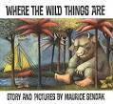
World Book Week
By Amber Smith and Zeba Kazi.
(Year 6)
To celebrate world book week and reading as a school, parents were invited to come in to read with their child/children in the mornings.
World Book Day was on 1st March. It is a day where everyone across the world celebrates reading.
We also had a book swap across year groups. Year 1 and Year 4, Nursery and Year 6 , Year 2 and Year 5 and finally, Reception and Year 3.

SATs INSPIRE
As we are coming closer to SATs, Year 2 and 6 had an inspire explaining about the process and how to get extra marks in the test. They were given dates and times and also got study–books for them to practise. We hope this will boost their results, and help them in their tests.
By Amber Smith and Zeba Kazi (Year 6)
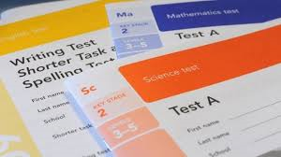

The Omelette Challenge
By Amber Smith (Year 6)

Schools across Newcastle took part in something called the Omelette Challenge. Each group of four children cooked an omelette and the judges gave them scores. The highest ranking team went to the final ( held at Excelsior academy). Moorside finished 3rd with a Score of 18.
Well done!

Kindness pizza!
By Amber Smith and Zeba Kazi (Year 6)
Teachers from each class nominated a child, who had good behaviour and was kind to others, to go to a special trip to the Metro centre as a reward. They went to Bella Italia (an Italian restaurant) to make and eat their own pizza! They also got ice cream as dessert. They all had a great time!

The children who were nominated were :
- Zara Kazi for being very kind and supportive to everyone.
- Renad Ahmed for always helping others, listening consistently and trying to show friends the right choice.
- Ted Chaffey for always helping his friends during mental maths and being kind and helpful.
- Tahsin Hoque for being kind and considerate towards all of her classmates and always trying to help others.
- Antonio Grecu for being kind to his friends, helping them when stuck and always being polite.
- Aleks Betcher for always being polite and helping others.
- Rahad Haider for being kind and respectful to everyone. Always a good friend.
- Sophie Cheel for always offering to help anyone who is struggling with their work.
- Kelsey Thomson for always trying to help people.
- Sara-Daiana Omar for being a constant help in every lesson and always helping others.
- Nafi Al-Nima for recognising that new children might be lonely and trying to play with them
- Arshan Chowdhury for showing great team spirit and being a good role model for collaboration.

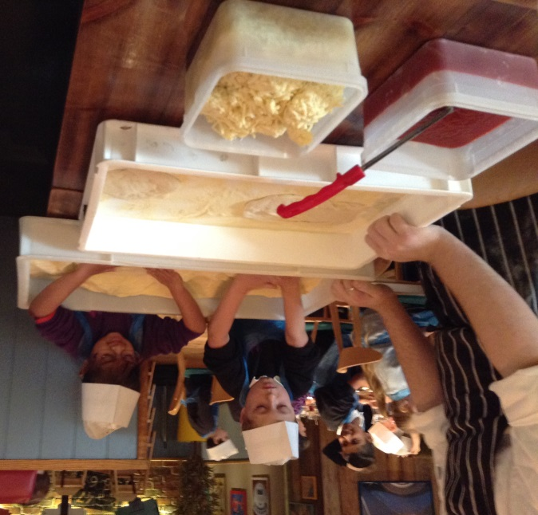
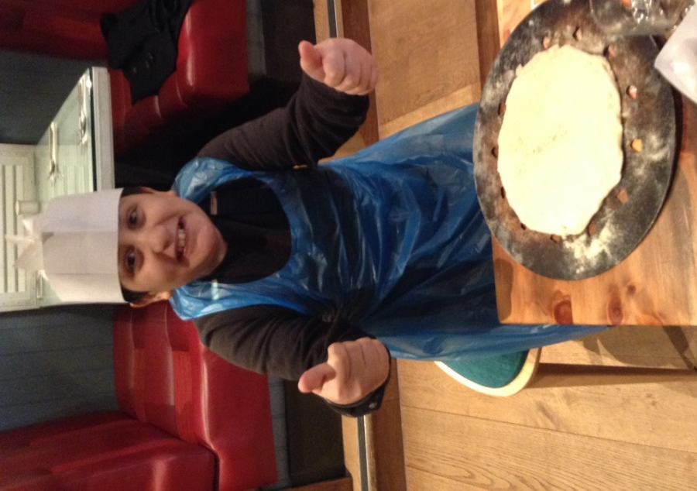
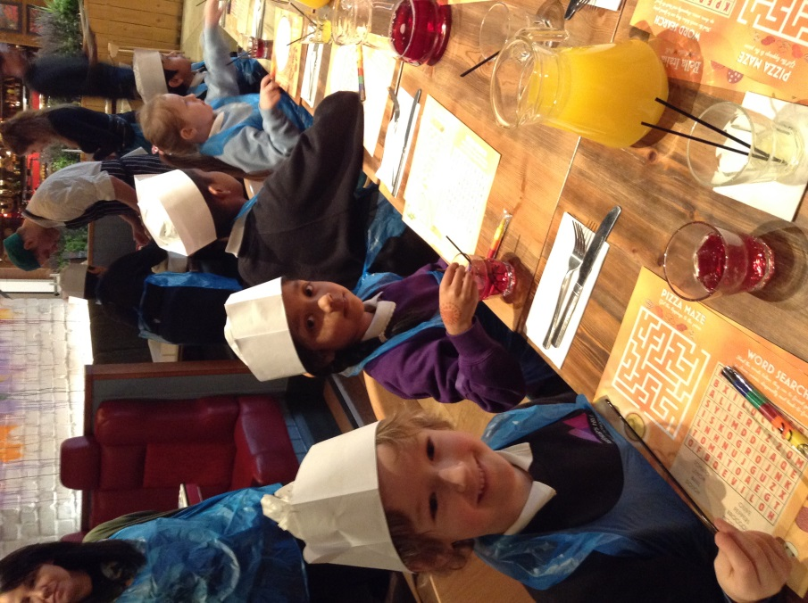

Well done to 6R for achieving 99.3% attendance!

w/c 19th February 2018

Stars of the Week!

Each week the teachers from Reception to Year 6 classes will select a child that they believe has worked really hard that week, has carried out something special or been exceptionally kind to someone. We will then share this in assembly on a Monday with others and present them with a certificate to acknowledge their hard work. Then throughout the rest of the week they will lead their class in and around school.

This week’s stars are:
- Aaya Gulli for her determination in writing to our elf.
- Zainab Hussain for settling well into her new class.
- Tyler Carruthers for always listening in group time.
- Praise Alexander for super maths using tens and ones.
- Elle-May Mills for great work in handwriting and sentence work.
- Manal Es Safiani for excellent mathematical skills when dividing by 2, 5 and 10.
- Mahm Nadeem for excellent use of vocabulary in her innovated story.
- Zidan Meah for trying his best when using money in maths.
- Nadia Shademan for settling in well and always working hard.
- Easa Ahmed for excellent effort in literacy especially when writing his introduction to his explanation text.
- Farhan Sultan for taking great effort to improve his hand writing and presentation.
- Eduard Dura for settling into his new class well.
- Suraya Begum for her excellent work calculating fractions and ordenals.
- Oxana Horvathova for excellent effort in writing – trying hard to work independently.
- Joseph Oyibo for working super hard to include Year 6 level writing features in his work.

Attendance w/c 05/02/2018:

Class | Attendance
RC | 97.4%
RL | 97.7%
1C | 85.7%
1CS | 89.3%
2A | 93.1%
2J | 91.4%
3G | 97.0%
3F | 99.0%
4W | 93.8%
4P | 95.0%
5S | 87.8%
5W | 93.1%
6B | 94.3%
6R | 99.3%

Stars of the Week!

We have combined Stars of the Week for week commencing 26th February 5th March due to World Book Week and the severe weather problems last week.

Weeks 26/02/2018 / 05/03/2018
- Ibrahim Ahmed for good recognition of numbers 1-20.
- Nabeela Karim for learning to read some tricky words on sight.
- Arhem Mohammad for working hard in Maths.
- Saqr Elsaadi for having a great attitude in class.
- Yara Khattab for trying so hard to make a riddle.
- Kamela El-Saadi for trying so hard with solving problems in Maths.
- Muhammad-Ans Ali for trying hard and listening carefully to others.
- Israt Karim for making a fantastic flying creature with Linda Lines.
- Aishah Khanum for working so hard with her handwriting and her sentence work.
- Najifa Hussan for her excellent explanation text.
- Wilf Chaffey for a super, well-structured poem, full of imagery.
- Gabriel Ionut Marodin for working hard to build relationships with others.
- Maleikah Mwingi for a great rhyming poem.
- Zunaira Noor for trying so hard with her reading and division work in Maths.
- Buthayna Ethni for trying so hard with her handwriting.
- Franklyn Jecco-Obi for knowing what to use to help him add up. Well done Franklyn you are doing a great job.
- Elodie Pitman for trying so hard with her reading.
- Ayaan Mehmood for trying so hard finding one more in Maths.
- Amy Bell for writing a fantastic narrative poem using some excellent vocabulary.

Well done to 3F for achieving 96.3% attendance!

Well done to 1C for achieving 99.3% attendance!

Attendance

Attendance w/c 26/02/2018:

Class | Attendance
RC | 94.3%
RL | 91.5%
1C | 93.5%
1CS | 85.3%
2A | 92.0%
2J | 90.5%
3G | 89.6%
3F | 96.3%
4W | 90.1%
4P | 96.1%
5S | 96.2%
5W | 83.1%
6B | 93.5%
6R | 92.7%

Attendance w/c 19/02/2018:

Class | Attendance
RC | 97.3%
RL | 94.4%
1C | 99.3%
1CS | 91.7%
2A | 96.9%
2J | 93.6%
3G | 94.3%
3F | 95.9%
4W | 98.1%
4P | 99.2%
5S | 95.0%
5W | 94.8%
6B | 91.4%
6R | 97.7%

