Start of the day – Try a different challenge each day

* Do 5 to 10 star jumps,
* Run on the spot for a minute.
* Jump on the spot.
* Walk for a minute.
* Try 5 big steps forward.

Maths

* With someone in your family clap hands and count to five – do this slowly then faster
* With the help of an adult or someone in your family please log onto this website and count the buttons on the Gingerbread man <https://www.topmarks.co.uk/learning-to-count/gingerbread-man-game>
* Stay on this website now and use the menu to go to the matching games and match the Gingerbread men to the trays
* Now give yourself and the adult five claps for working hard on your counting.

onto <https://classroom.thenational.academy/lessons/count-one-and-two-objects-reliably-71h3jc>

Sing along counting about cars. <https://www.bbc.co.uk/iplayer/episode/p077rl69/numbersongs-counting-cars>

<https://go.educationcity.com/content_select/index/1/2/1/1#/c=41862>

https://go.educationcity.com/content_select/index/1/2/1/1#/c=42652

Literacy – remember this story tell someone in your family this story using the pictures. What was in the basket at the end?

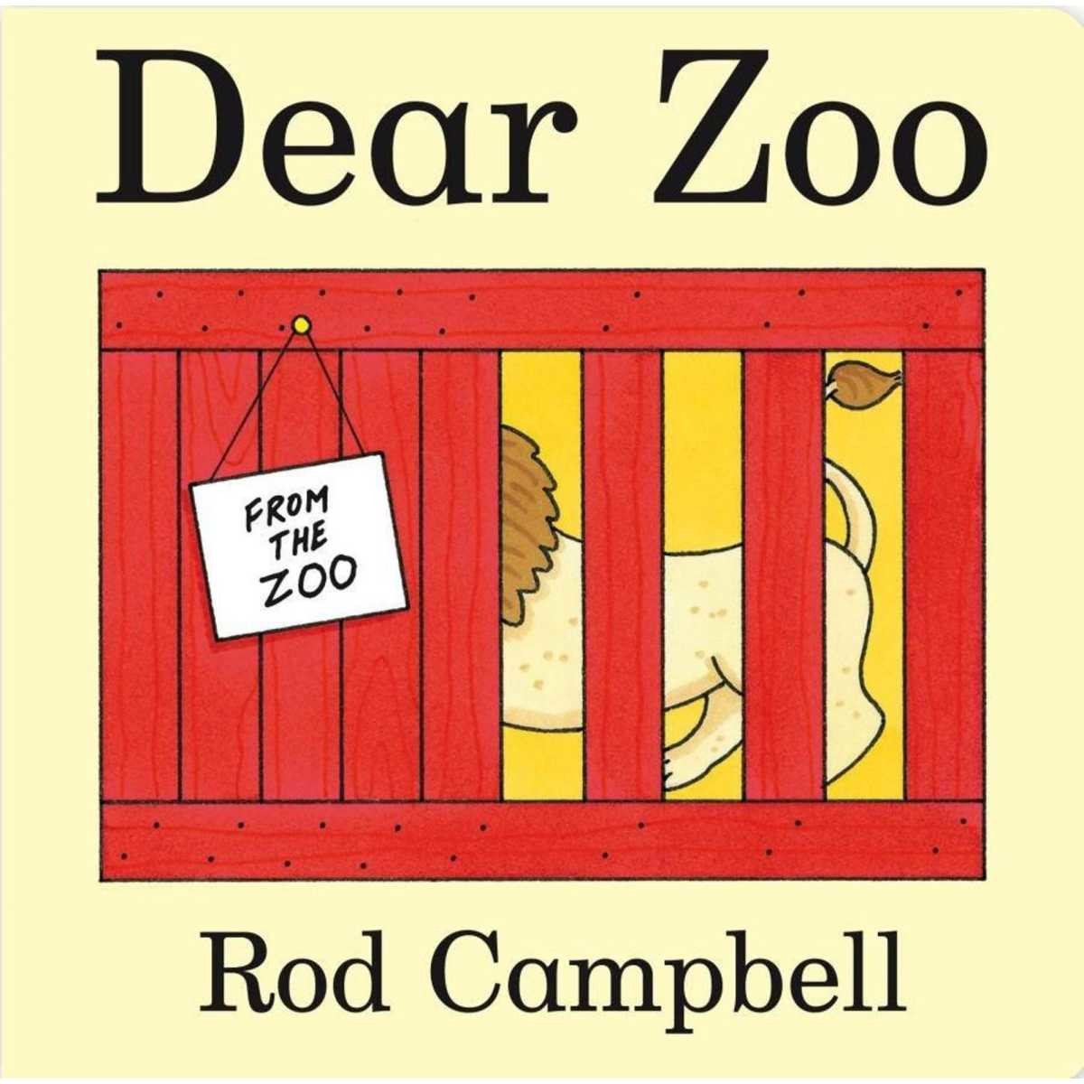 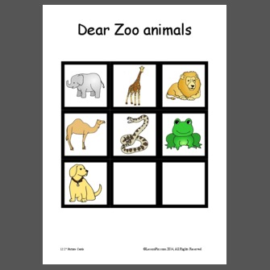 Which pet would you choose?

Remember school website is: www.moorside.newcastle.sch.uk/website

If stuck email [Linda.hall@moorside.newcastle.sch.uk](mailto:Linda.hall@moorside.newcastle.sch.uk)

Songs and rhymes log on and learn:

* Baa Baa Black Sheep
* Polly Put the Kettle on
* Five Little Monkeys Jumping on the bed

<https://www.bbc.co.uk/teach/school-radio/nursery-rhymes-a-to-z-index/z4ddgwx>

With someone in your family, learn some actions to go with these rhymes