Learning intention: To identify and describe the properties of 3D shapes, including the number of edges, vertices and faces.

Tick the correct number of vertices.

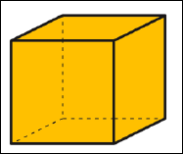 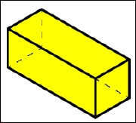

5 6

8 4

7 6

8 4

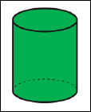 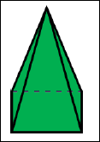

0 6

5 4

0 6

8 4

Tick the shape that has more than five vertices.

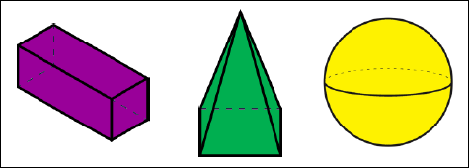

Tick the shape that has fewer than 6 vertices

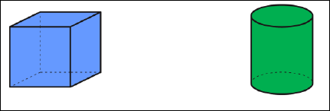

Challenge

