**Maths**

4cm

2cm

3cm

7cm

5cm

5cm

Area of a rectangle

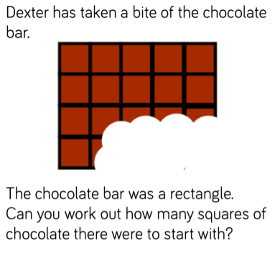

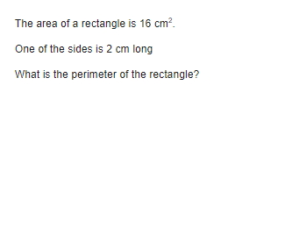

2cm

How many different rectangles can you draw with an area of 12cm2?

6cm

4cm

8cm

8cm

25cm

5cm