

**SCHOOL UNIFORM**

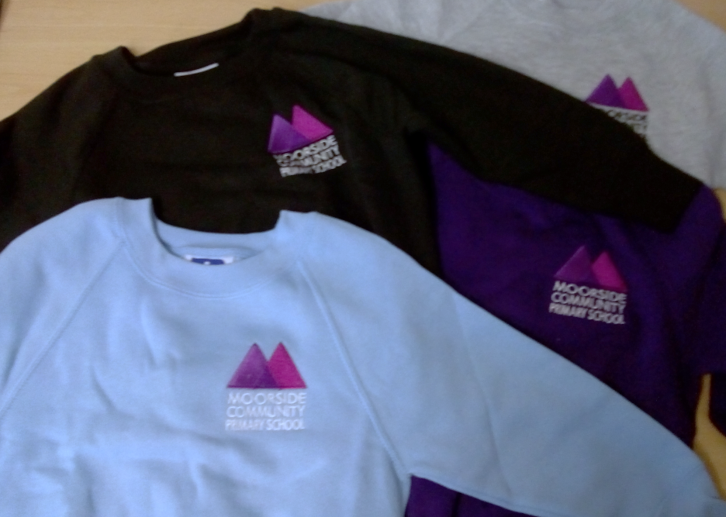

Sweatshirts are available at **£8.00** each and can be purchased from the school reception. They are available in purple, grey, light blue and black. Cardigans are available to order at **£9.50** each.

In addition to the school sweatshirt the following uniform should be adhered to…

**Girls**  
Dark black/grey skirt or trousers  
White shirt or polo shirt  
Black shoes

**Boys**  
Dark black/grey trousers  
White shirt or polo shirt  
Black Shoes.

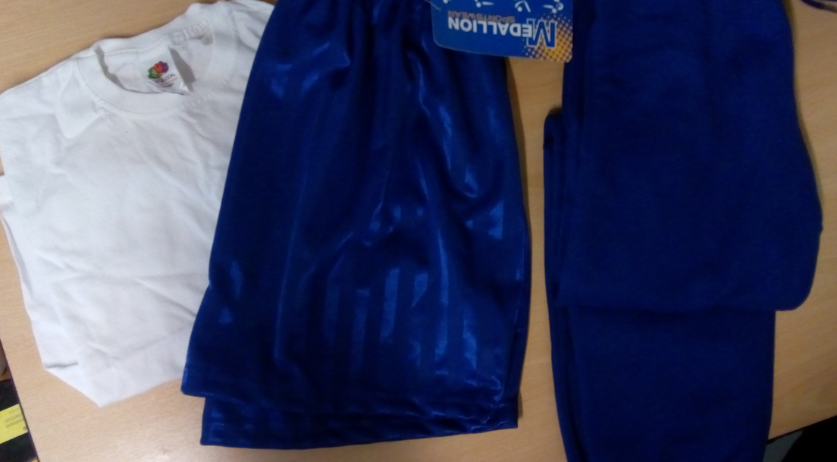

**P.E. Kits** are provided **free of charge** when a child first joins the school. This includes a white t-shirt, blue shorts and blue jogging pants.

Any replacement items can be purchased from the school reception at the following prices:

T-Shirt **£4.50**

Shorts **£4.50**

JoggingPants **£8.00**

Additional uniform can be purchased from any local retailer, including Tesco and Asda.

Book bags with the school logo are available from the office for **£5.00**.

Parents are reminded trainers are not permitted unless during P.E. and **no pupil should wear jewellery** for school except for a watch.