Start of the day – Do 10 pencil jumps, 10 star jumps and 10 tuck jumps.

Task one – Maths
Links - maths – TTRockstars
https://play.ttrockstars.com/auth

Remember school website is:
If stuck email Linda.hall@moorside.newcastle.sch.uk or
admin@moorside.newcastle.sch.uk

Reading
Read your guided reading book . Summarise the key events from the story.
Write a 50 word summary
Write a 20 word summary
Write a 2 word summary
Or create a story map.

Science Links
https://www.bbc.co.uk/bitesize/topics/zf66fg8/articles/zqbm3k7

Task one – English https://www.oxfordowl.co.uk/
Education city - https://go.educationcity.com/
BBC Bitesize https://www.bbc.co.uk/bitesize/levels/z3g4d2p

Task one – English
- CGP GPS Modal Verbs
- CGP English Autumn Term Workout 12

Science
Read Sir Isaac Newton’s biography and answer the questions.

Task 1
Ravi has been practising his column method but he has made some mistakes. For each sum, identify the mistakes and explain what he has done.
Can you correct them?
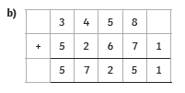
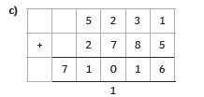

- Amy is playing a maths game. She scores 1200 in the first round, 4800 in the next round and 11,000 in the final round. Would you use column addition to find her total score? Use the numbers in the question to explain your answer.

Task two
Can you identify the missing numbers?
