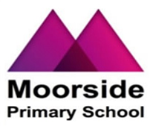  
  
  
  
  
  
  
  
  
  
  
  
  
  
  
  
  
  
  
  
  
  
  
  
  
  
  
  
  
  
  
  
  
  
  
  
  
  
  
  
  
  
  
  
  
  
  
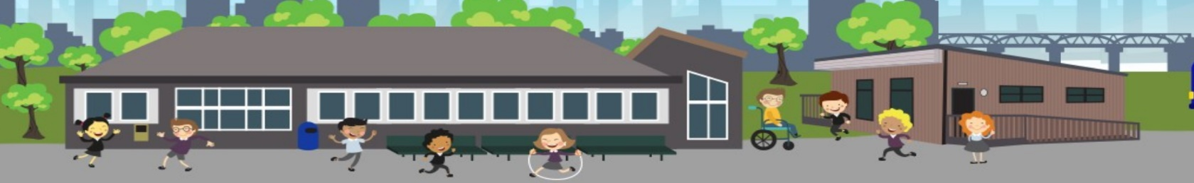

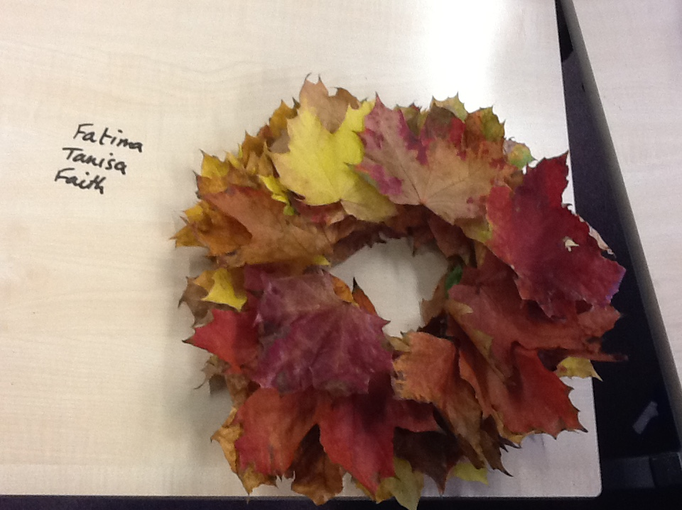

A **BIG** thank you to all who joined us for our harvest assembly. As usual, the turnout was exceptional. It is always lovely to see you and to share our learning.

**Year 2:**

In History, year 2 have been learning about how the Great Fire of London started in a bakery. They made bread rolls and practised writing instructions for how to make them in English.

**Challenge**

**In the Great Fire of London, which street was the famous bakers on?**

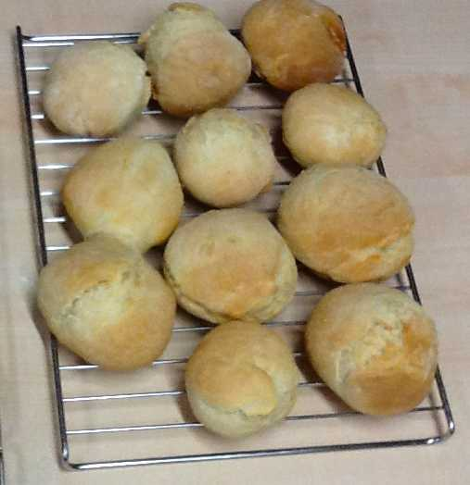

**Year 4:**

Year 4 have enjoyed exploring the sculptures of Andy Goldsworthy. They made some beautiful leaf sculptures inspired by his work.

They have learnt lots of new geographical facts as part of our topic about Russia.

**Challenge**

**Explain to your parents what a continent is and name them.**

**Year 6**

Year 6 held their annual cake and coffee morning this month to raise money for Macmillan. They raised an impressive £110!

A big thank you is to go to Mrs Gabbitus, who returned to help year 6 pupils bake for the event.

Children carried out research into the charity and presented their work on the computer.

**Moorside Primary School**

**Newsletter**

Ask your child about the artist Henry Moore.

Teach your parents how to count in French!

**Year 3**

Year 3’s topic this term is The Stone Age -they have looked at cave paintings and compared homes from then to now.

Thursdays have become a highlight of the week with swimming lessons. Children have been learning how to blow bubbles to help with their breathing.



**Year 5:**

This half term, year five have been investigating forces and the effects these have on an object. They have investigated air resistance by making different size parachutes to see which would fall the slowest. Then they tried to make the most streamlined boat to identify the effects water resistance has on an object. They also investigated why unsupported objects fall towards the Earth using a Newton meter.

**Playgroup:**

Playgroup have been learning “all about me”. They have been settling into their new daily routine with a Hello Song to learn each other’s names. They have also been sharing the story of the three billy goats gruff and taken this into their outdoor learning area.

**Dates for the diary:**

Half term holiday break up 26.10.18 – return to school 5.11.18

Y6 parents – closing date for application for Y7 31.10.18

Parents Evening week commencing - 12. 11. 18 – watch out for your letter of invitation after the half term break.

Y4 visit to Segedunum: 4P 16.11.18/ 4R 24.11.18. Letters will be coming out after half term to tell you about this visit.

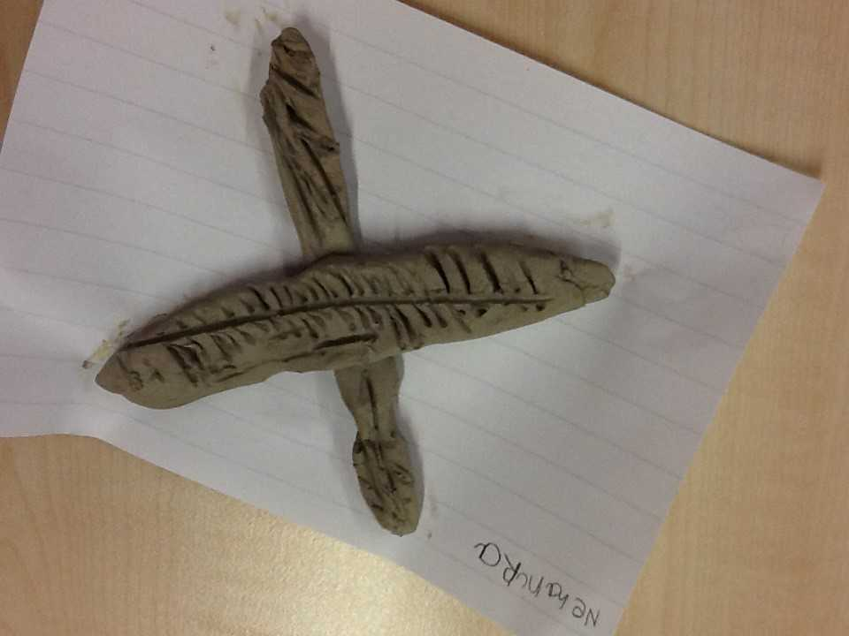

**Year 1:**

Year 1 have been learning about Anthony Gormley. They used clay to make the Angel of the North.

**Challenge**

**Where is the Angel of the North?**

What did the troll say to the Billy Goats?

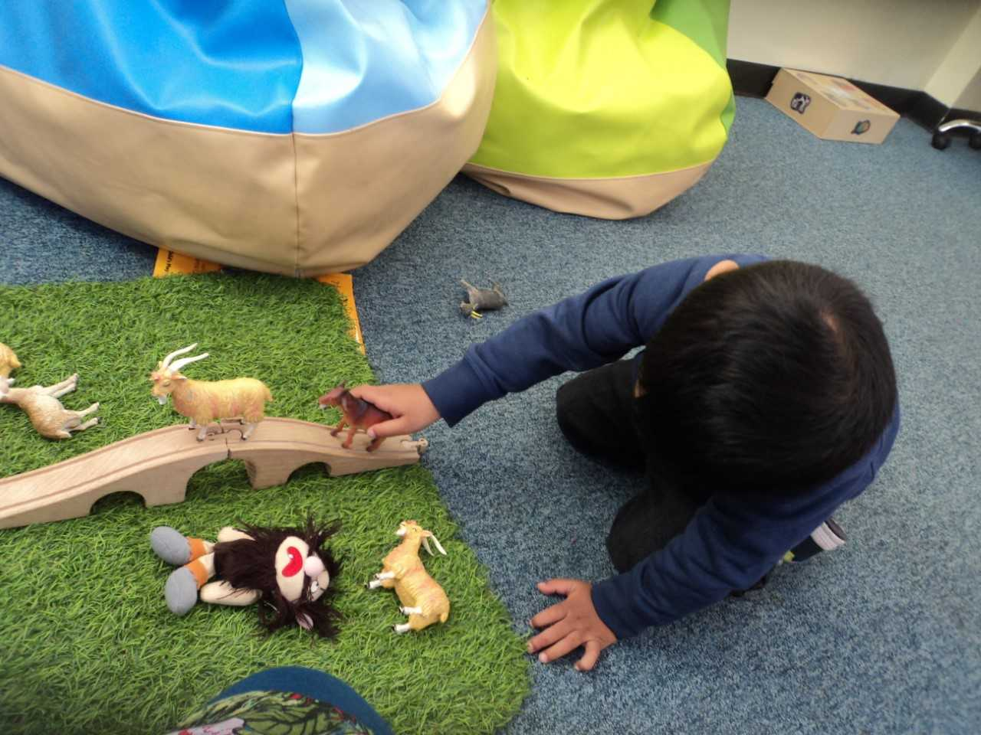

Can you identify the different forces on a boat, car and a parachute?

How many chairs does Goldilocks break?

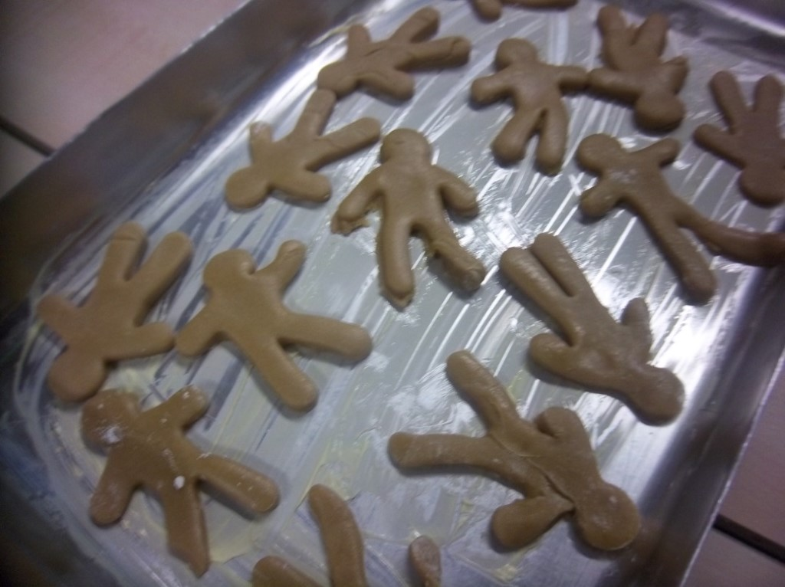

**Reception:**

Reception have been learning to recall the story of the Gingerbread Man. They have acted out the story wearing props and masks and using small world to retell the story. They even had the chance to make some – they tasted yummy!

**Challenge**

**What does the Gingerbread Man say to everyone who tries to catch him?**

**Nursery:**

Nursery have been exploring 2D shapes and have been on a hunt in the environment to find similar shapes in their classroom.   
They have been reading Goldilocks and the Three Bears; retelling the story and acting it out in the role play area using props.   
They have been learning how to look after each other too