  
  
  
  
  
  
  
  
  
  
  
  
  
  
  
  
  
  
  
  
  
  
  
  
  
  
  
  
  
  
  
  
  
  
  
  
  
  
  
  
  
  
  
  
  
  
  
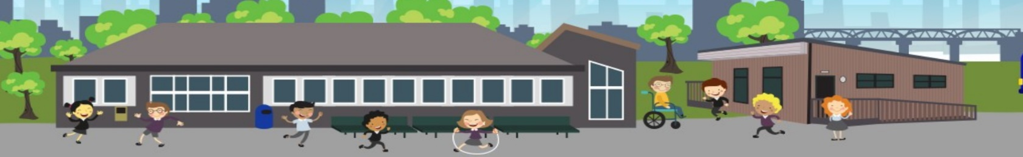

**Moorside Primary School**

**Newsletter**

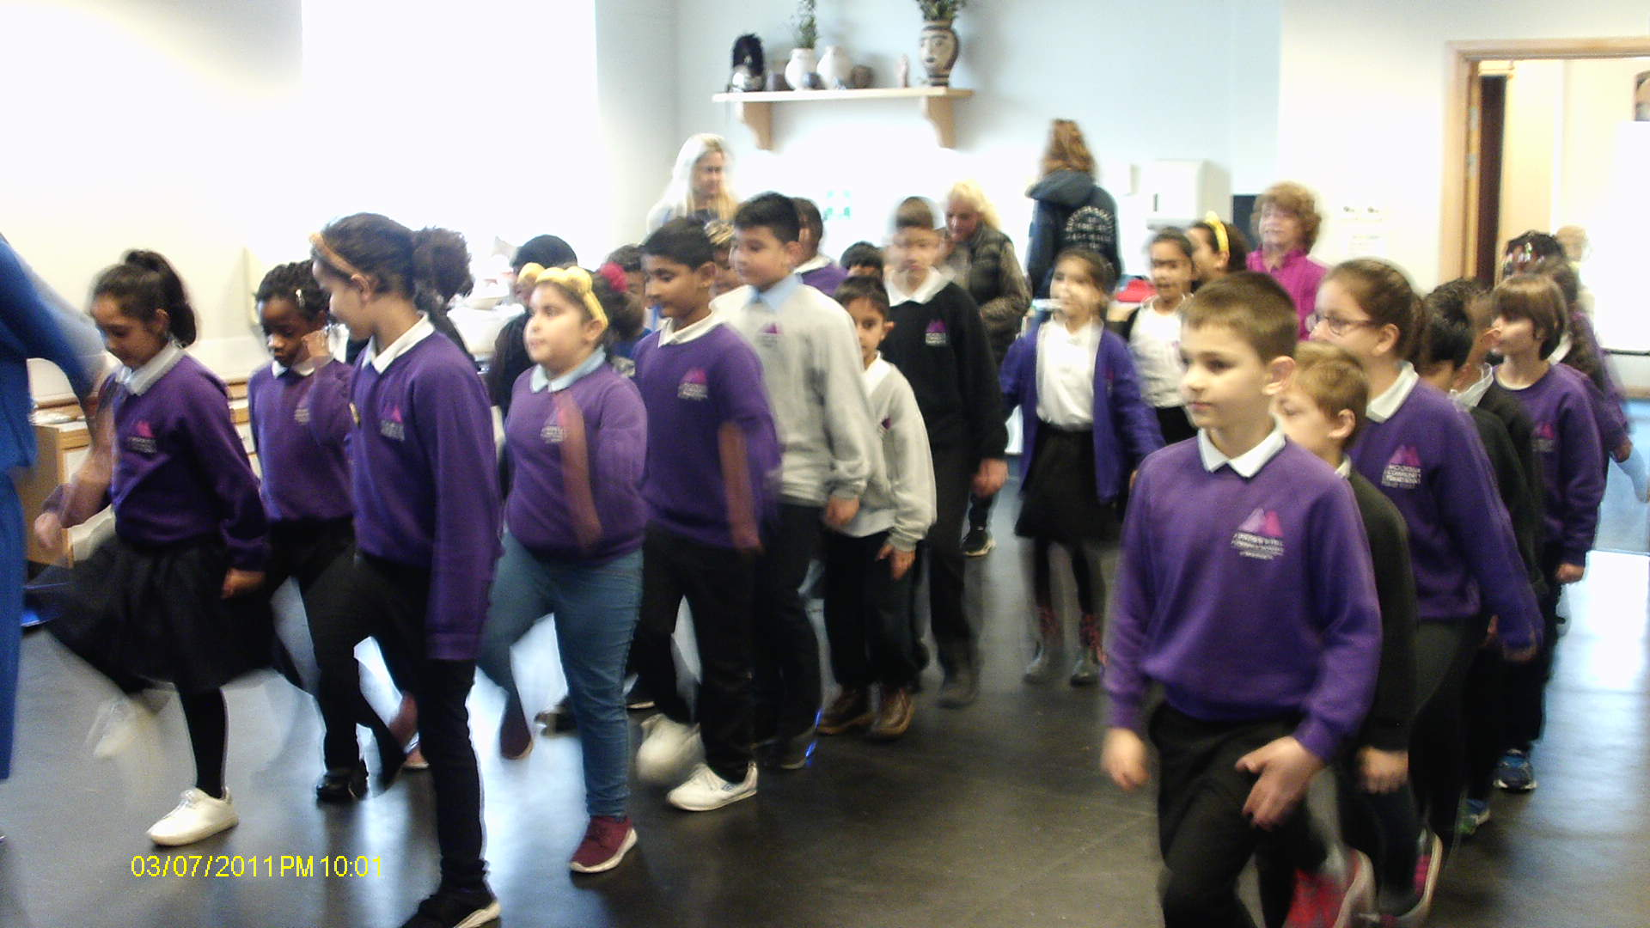

The Roman soldiers learnt how to march as a group..

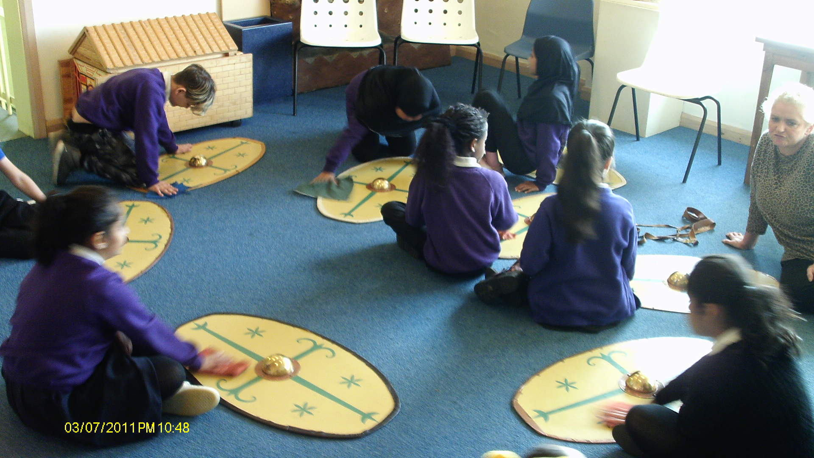

The soldiers polished their shields.

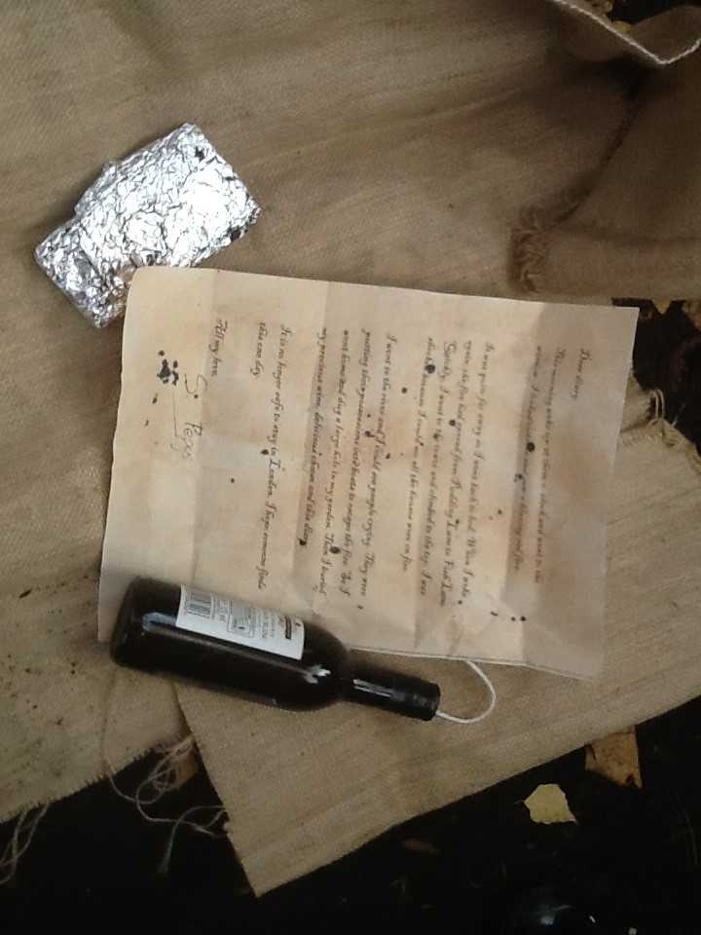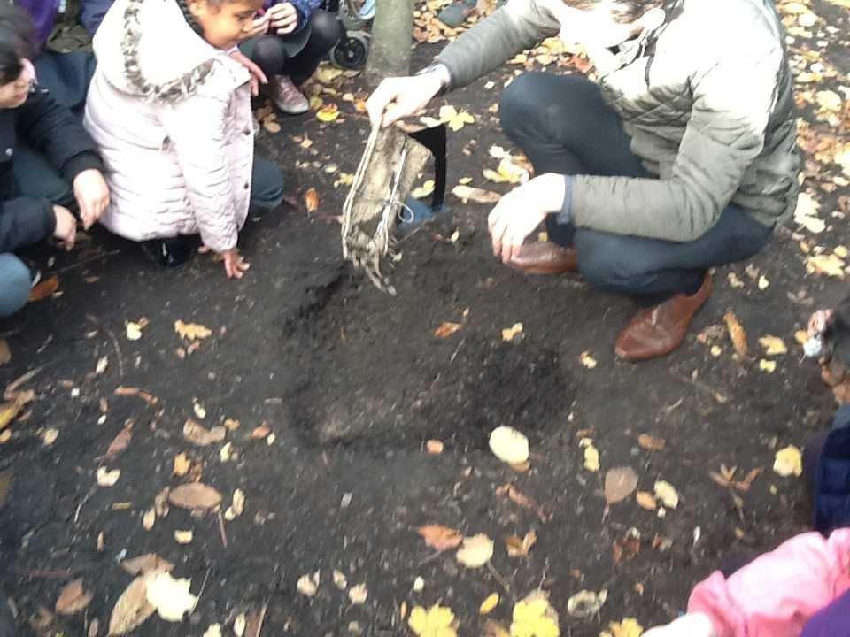

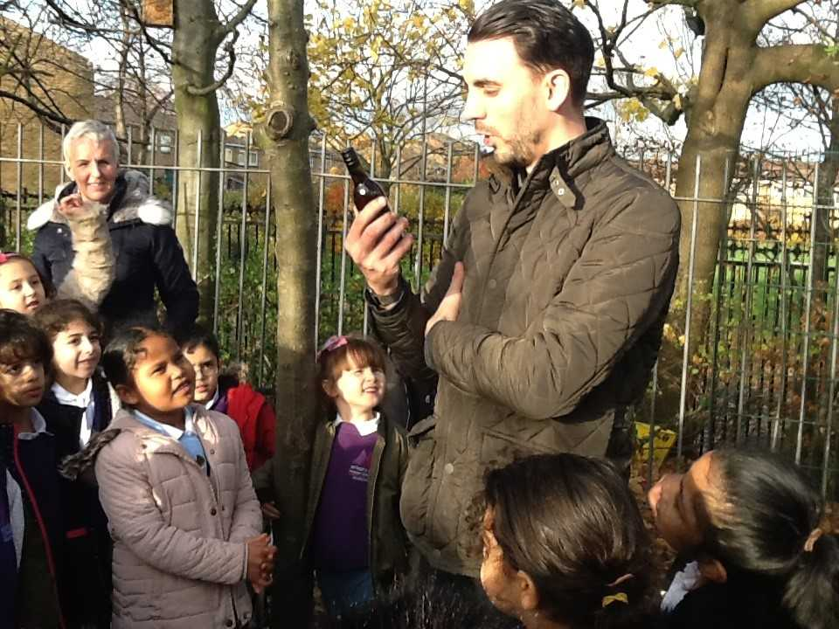



Explain to an adult who was involved in WWII.

**Year 3**

Recently, in Year 3, we have been working really hard to learn our times tables and division facts, using bar models to help us see the relationship between multiplication and division. We are thoroughly enjoying our volcano topic in geography, especially icing biscuits to help us remember the four layers of the Earth. In science, we have also started a new topic on Light and Dark so we can tell you lots of different light sources.

Why wouldn’t we be able to see the moon without the Sun?

**Year 6**

Year 6 have been creating art inspired by scenes from World War Two.

They are looking forward to a visit from Mrs MacDonald’s Dad, who is coming in to talk to them about his experience of war time.

A **BIG** thank you to all who donated to children in need last week. We raised a fantastic £185!

**Year 2:**

Year 2 have been digging for precious possessions belonging to Samuel Pepys as part of our Great Fire of London topic.

**Challenge:**

**What is Samuel Pepys**

**famous for?**

**Year 4:**

Year 4 have continued to learn about Ancient Rome and their invasion of Britain to expand their Empire. They visited Segedunum fort to learn what it was like to be a Roman soldier.

**Challenge:**

**What language did your officer speak in at the Roman fort?**



Tell a grown up, three things that happen to Stickman on his journey.

Which piece of Henri Rousseau’s have you liked the best and why?

What did you explore?

**Year 1:**

Year 1 have been enjoying our music lessons every Wednesday morning with the teachers from the Newcastle Music Service. We have loved learning new songs about the seasons and playing instruments. We were very excited when we heard the saxophone and clarinet.

**Challenge: Sing your autumn song to an adult**

**Playgroup:**

Playgroup have been using their senses to explore items in their play. They have talked about how things look and feel.

.

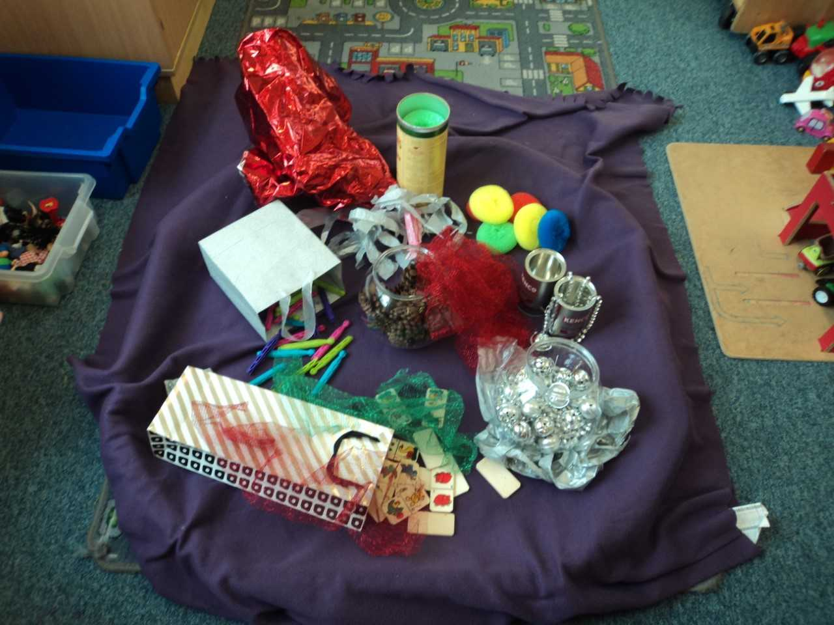

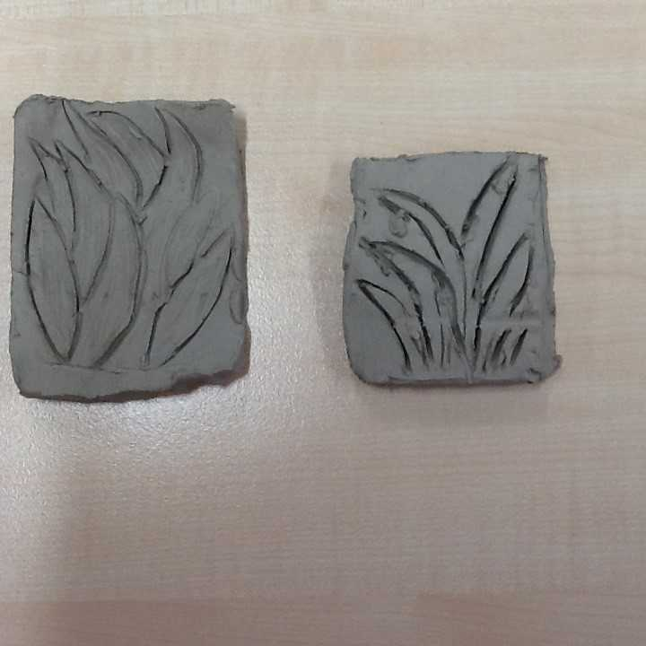

**Year 5:**

Year 5 have explored different ways to create prints in art. We have designed and made our own printing blocks, using clay, based around the designs of artist; Henri Rousseau. When they have dried, we will be able to add paint to see the different prints we have created.



**Reception:**

Reception have been learning all about Divali. They have enjoyed making diva lamps, Mendi patterns, rangoli pictures and dancing to Divali music.   
Happy Divali!

**Challenge:**

**Tell an adult why Hindu people light diva lamps.**

**Nursery:**

This half term in Nursery we are exploring and reading the book Stickman. We have also made our own stickmen by collecting sticks from outside!

We have been counting from 1 to 10 and matching quantity to numerals in our maths group time.