Can you help Goldilocks along the dotted lines?

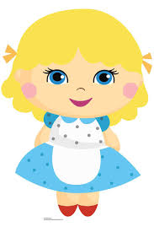

C:\Users\Sandra Jepson\Desktop\bears\patterns 1.jpg





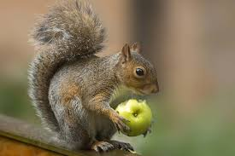

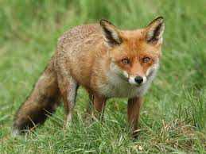C:\Users\Sandra Jepson\Desktop\bears\patterns 5.jpgC:\Users\Sandra Jepson\Desktop\bears\patterns 5.jpgC:\Users\Sandra Jepson\Desktop\bears\patterns 2.jpgC:\Users\Sandra Jepson\Desktop\bears\patterns 3.jpg