Can you help Goldilocks find some things?

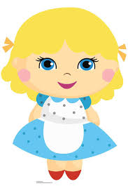

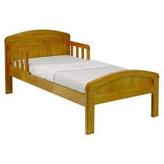

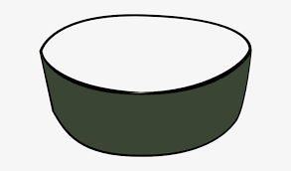C:\Users\Sandra Jepson\Desktop\bears\patterns 2.jpgC:\Users\Sandra Jepson\Desktop\bears\patterns 2.jpg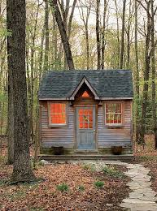C:\Users\Sandra Jepson\Desktop\bears\patterns 3.jpgC:\Users\Sandra Jepson\Desktop\bears\patterns 3.jpgC:\Users\Sandra Jepson\Desktop\bears\patterns 4.jpg