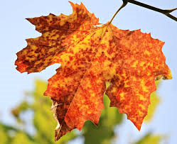

Wednesday 11th October 2017
Dear Parents/Carers,

RE: Autumn Assemblies

We would like to invite you to our Autumn Assemblies taking place next week. In these assemblies, we will be sharing your children’s learning from this half term.

In addition, we would like to take this opportunity as a school to support local families in need and would like to ask for donations of food that we can distribute to help our local community.

There will be two assemblies and the classes will be split as follows:
Tuesday 17th October 9:15am | Wednesday 18th October 9:15am
1C | 1L
1CS | 2J
2A | 3R
3G | 4P
4L | 5W
5S | 6W
6B | 6R

Kind Regards

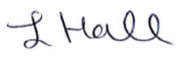

L. Hall
Headteacher
Moorside Community Primary School

