Week Twelve
Aphid Farming
Did you know that ants keep aphids, a bit like humans keep cows?
Aphids are small sap-sucking insects such as greenflies and blackflies.
Ants even sometimes milk them!
The aphids are protected by the ants from predators such as lady birds. In return, the ants collect and eat the ‘honeydew’, which the aphids produce from eating the sugary sap of plants.
This relationship is called a symbiotic relationship, as it is beneficial to both the aphids and the ants.

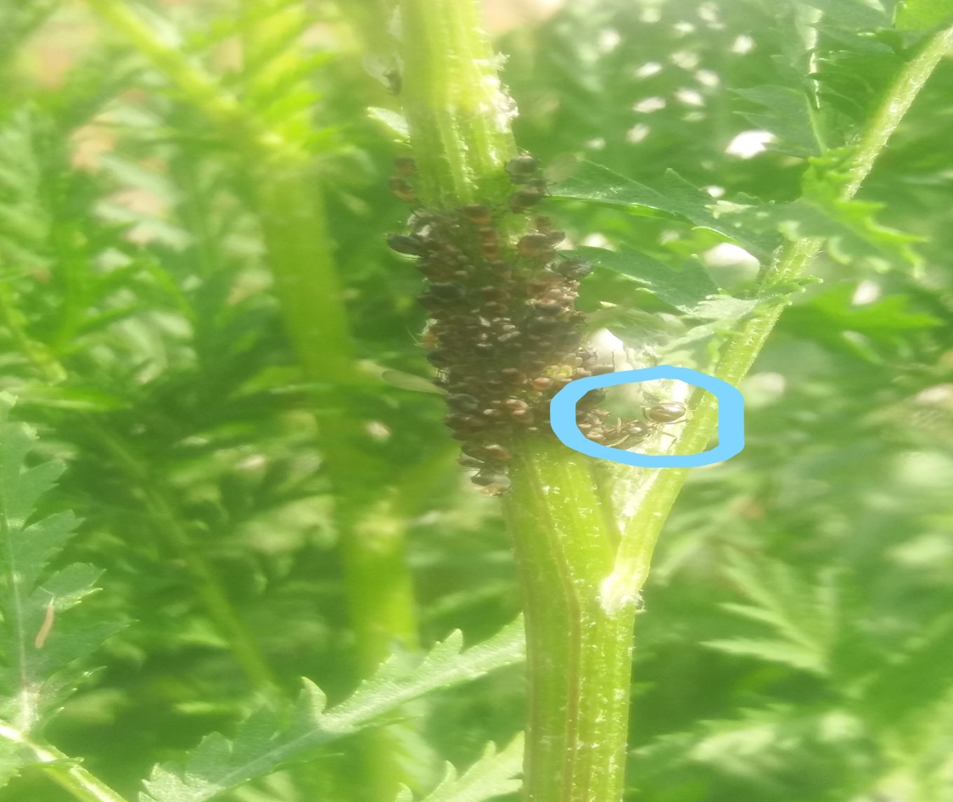
Have a look in your garden and see if you can spot any relationships of your own!

