Moorside Community Primary School
Beaconsfield Street
Newcastle upon Tyne
NE4 5AW
Telephone: 0191 272 0239
Email: admin@moorside.newcastle.sch.uk

Head Teacher: L Hall
Email: linda.hall@moorside.newcastle.sch.uk
26th June 2018
Dear Parents, Staff and Stakeholders.
CONSULTATION TO CONVERT TO A FOUNDATION TRUST AND JOIN WEST END SCHOOLS’ TRUST
Further to the initial consultation with regard to our proposal to join the West End Schools’ Trust the Governors have decided to proceed to the next stage. This was formally agreed at a full governing body meeting held on the 21st June 2018.
This letter marks the start of a statutory 4 week ‘representation period’. As the period will end during the school holidays we will write to everyone in September to update them further.
During the representation period any person may object to or make comments on the proposals by sending them to the Head Teacher or the Chair of Governors at the address above.
We have outlined the written results from initial consultation for your information. We did receive a high number of verbal replies in addition to the written replies and would like to thank everyone for their support.
Number sent | Sent to | Replies Received | Enthusiastic | Support | Not sure | Do not support
480 | Parents | 29 | 2 | 24 | 1 | 2
70 | Staff | 25 | 7 | 17 | 1 | 0
100 | Stakeholders | 3 | 2 | 1 | 0 | 0
Total Sent | 650 | 57 | 11 | 42 | 2 | 2

Sent out | Sent to | Replies Received | Excited | Good Idea | Not sure | Do not like the idea
230 | Pupils | 121 | 36 | 51 | 17 | 17

Yours sincerely
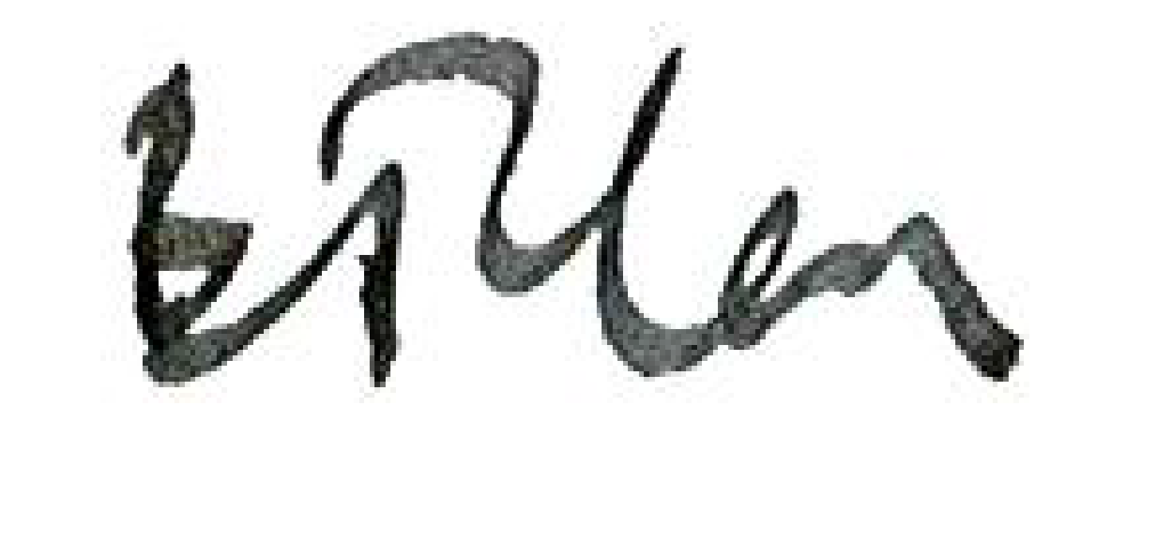
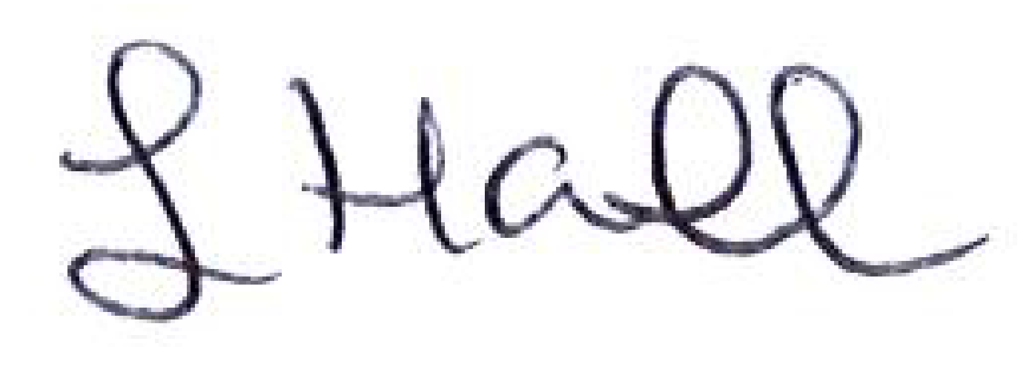
L Hall B Clark
Head Teacher Vice Chair
Moorside Community Primary School Moorside Primary School Governing Body

