**Moorside Community Primary School**

Moorside Community Primary School

Newsletter

*Diary Dates – November 2017*

**Family Learning**

***Tuesday*** - 9.15-11.15 Story Sacks for parents/carers of Nursery and Reception classes.

***Wednesday***- 9.15 -11.15 Phonics Read Write Inc. for parents/carers of Reception classes.

***Thursday*** 13.15-15.15 Family Language.

*Tuesday: Samba – Y6*

*Wednesday: Trumpets – Y4*

*Thursday: Swimming – Y3*

This week in school we have celebrated Harvest festival. As always, thank you for the donations of food items brought into school that will be shared with those in need locally.

For Years 1-6 a celebration work assembly took place to allow the children to share their learning with parents and carers. It was fantastic to see so many proud faces from both the adults and children themselves.

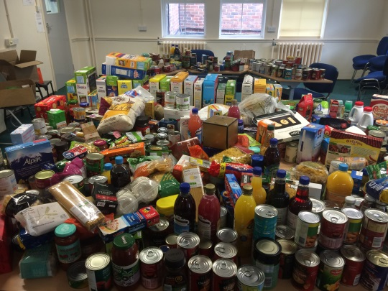

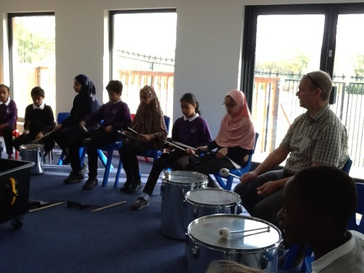

This half term Y6 have been lucky enough to participate in Samba. Each week, the pupils have been learning how to play a range of musical instruments including: agogo bells, tamborims, surdos and ganzas.

Particular focus has been on playing the different instruments in collaboration, keeping to a set beat.

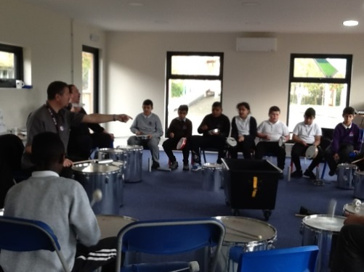

During Samba I have been learning to play the surdo drums. I find it fun to play, although I am looking forward to playing more complex music next half term.

Arshan Chowdhury Y6

A

**w/c 16th October 2017**

Well done to **5S** for the highest attendance in school at **100%**!!!

**Stars of the Week!**

Each week the teachers from Reception to Year 6 classes will select a child that they believe has worked really hard that week, has carried out something special or been exceptionally kind to someone. We will then share this in assembly on a Monday with others and present them with a certificate to acknowledge their hard work. Then throughout the rest of the week they will lead their class in and around school.

This week’s stars are:

* Michelle Ruan (RC): always setting a good example.
* Peter Balogova (RW): excellent work in construction.
* Mohammad Sultan (Amar)(1C): always contributing in all lessons.
* Jana Adabashi(1CS): for good use of vocabulary and working hard.
* Mohammad Farhan(1L): super blending in reading.
* Adon Ahmed Hoshien (2A): for settling in and being a kind and helpful class member.
* Alae Zahrani(2J): working independently in maths when counting in 2’s, 5’s and 10’s.
* Jack Mayne (Ozzy) (3G): fantastic work in science working independently to explain how rock turns into soil.
* Nathan Pears (3R): remembering lots of facts about rocks and fossils.
* Iveta Danova (4L): excellent attitude to the Iron Man text.
* Shayma Alghamdi (4P): settling into Moorside well.
* Rhys McKeown Foley (5S): persistent hard work and determination.
* Tayyibah Nahar(5W): trying her hardest in each lesson.
* Nisha Naziat Ahmed(6B): an excellent start to year 6—polite, conscientious and hardworking! Keep it up!
* Fizzah Nawaz(6R): clearly working very hard to learn her times tables.
* Zunaira Noor(6W): trying very hard to verbalise sentences.

Attendance w/c 16/10/2017:

|  |  |
| --- | --- |
| Class | Attendance |
| RC | 89.6% |
| RW | 79.6% |
| 1C | 96.5% |
| 1CS | 95.3% |
| 1L | 90.0% |
| 2A | 94.3% |
| 2J | 95.3% |
| 3G | 90.3% |
| 3R | 94.5% |
| 4L | 91.1% |
| 4P | 94.8% |
| 5S | 100% |
| 5W | 90.0% |
| 6B | 92.2% |
| 6R | 97.8% |
| 6W | 90.6% |

**Please note in the 2nd week back after half term we will hold Parents Consultations for the whole school. Look out for the dates and sign-up sheets on the first week back in the school entrance.**