Child Friendly Behaviour Policy

Behaving in class
Looking after school stationary
In class you must always look after the school stationary. For an example: Always put the pens and pencils in the pencil pots.

Actively listening
When the teacher is talking you must always listen to them and show it: turning around your chair and dropping whatever you have in your hand or closing whatever you are looking at.
Keeping safe on visits
Uniform
On visits, you must wear uniform at all times. (Unless you have been told otherwise) This is so that if you are separated from the class, you can show people your jumper and they can call the school.
Groups and Partners
On visits you may be put in partners and groups. This is to keep you safe so you must stay in these groups.
Coach
When the trip is further away, you will take a coach. Here are some rules to keep you safe:
- Fasten your seatbelts
- Listen to your teacher for instructions
- Say thank you to the driver
Behaving well on the yard
Playtime
Inappropriate games
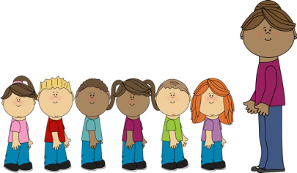
At playtime you must not fight other people because someone else will get hurt. If you see someone fighting you must tell a teacher.

Lining up
When the whistle is blown by a teacher you must line up straight away in your in your line.

Lunchtime
Respect lunchtime staff
At lunchtime you must respect the staff like, you would respect your teacher.
Basket ball
When you have a basketball and it’s your turn to go inside for your lunch give the ball to someone else don’t then ask for it back. If you are playing and someone ask you can I play with do not say NO!
When you have the basketball do not fight just play nicely with your friends.
Equipment
If there is equipment on the yard such as: skipping rope, hula hoops, you must behave well with them or the equipment will be taken off from you.

