Year Two English
Features of instructions
Use the PowerPoint to remind you of the features of instructions. You can listen to the teacher read the second part of the story or read it by yourself here.
Can you spot the features of instructions in the rest of the text? How many instructions can you find?
Instructions
By Neil Gaiman
The river can be crossed by the ferry. The ferryman will take you. (The answer to his question is this: if he hands the oar to his passenger, he will be free to leave the boat. Only tell him this from a safe distance.
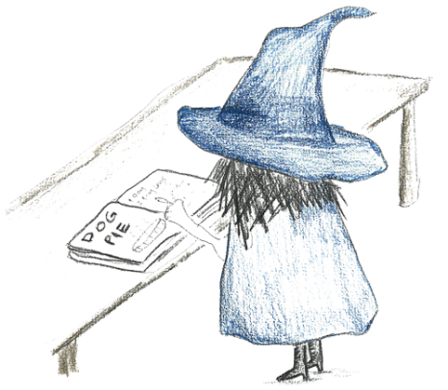
If an eagle gives you a feather, keep it safe.
Remember: that giants sleep too soundly; that witches are often betrayed by their appetite; dragons have one soft spot, somewhere, always; hearts can be well hidden, and you betray them with your tongue.
Do not be jealous of your sister: know that diamonds and roses are as uncomfortable when they tumble from your lips as toads and frogs: colder, too, and sharper, and they cut.
Remember your name. Do not lose hope – what you seek will be found.
Trust ghosts. Trust those that you have helped to help you in their turn. Trust dreams. Trust your heart, and trust your story.
When you come back, return the way you came. Favours will be returned, debts will be repaid. Do not forget your manners. Do not look back.
Ride the wise eagle (you shall not fall). Ride the silver fish (you will not drown). Ride the grey wolf (hold tightly to his fur).
There is a worm at the heart of the tower; that is why it will not stand.
When you reach the little house, the place your journey started, you will recognise it, although it will seem much smaller than you remember. Walk up the path, and through the garden gate you never saw but once.
And then go home. Or make a home. Or rest.

