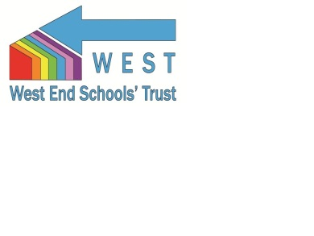
The West End Schools' Trust (WEST) is a foundation trust of eight primary schools located in the inner west of the city of Newcastle upon Tyne. We are responsible for the education of nearly three thousand pupils between the ages of 3 months and 11 years. We are a strong learning community where our pupils have highly positive experiences and attain good standards.
Our school catchments cover an area of ten square miles that are bordered by the River Tyne, the Northumberland County boundary and the main conurbation of the City of Newcastle. We have a rich industrial and historic heritage with Hadrian’s Wall bisecting our cluster. Our catchments are socio-economically mixed. When pupils leave our schools they are well prepared for the next phase of their educational journey with standards at, and above, the national averages in reading, writing and mathematics. All of our schools are unique and although they may vary in size and context, Ofsted inspections for our cluster reveal effective schools that work in collaboration for the benefit of the whole of our community.
Currently we employ nearly three hundred teachers, teaching assistants and administrative staff. Our leadership teams of experienced headteachers and governors, deputy and assistant headteachers and school business managers have proven track records of school improvement. The Trust strengthens the schools’ collaborative work with key partners identified to further improve standards and enhance opportunities for children, parents, staff and the wider community.
Our eight schools are Bridgewater, Broadwood Primary School, Canning Street Primary School, Hawthorn Primary School, Moorside Primary School, St John's Primary School, St Paul's Primary School and Wingrove Primary School.
All of our schools share:
• A warm and welcoming ethos;
• Good and outstanding teaching and learning;
• Educational achievement that is in line with or above national expectation;
• Multicultural, highly inclusive and cohesive school communities.

