**Start of the day – Try a different challenge each day**

* 5 hops on one foot then on the other foot
* Jump across the room and back
* 5 star jumps.
* 10 large steps forward and 5 steps back carefully
* Stand on one foot and count to 5

Maths

* Sing ‘Two little Dicly Birds sitting on a wall’.
* With someone in your family clap hands and count to six – do this slowly then faster
* With the help of an adult or someone in your family please log onto this website and do some counting with the bear <https://www.topmarks.co.uk/learning-to-count/teddy-numbers>
* Count how many bears there are in Peace at Last

onto <https://classroom.thenational.academy/lessons/count-one-and-two-objects-reliably-71h3jc>

Sing along counting about cars. <https://www.bbc.co.uk/iplayer/episode/p077rl69/numbersongs-counting-cars>

<https://go.educationcity.com/content_select/index/1/2/1/1#/c=41862>

https://go.educationcity.com/content_select/index/1/2/1/1#/c=42652

Literacy –

Use the PowerPoint in your folder to share the story Peace at Last. When you have shared it, talk to someone in your family about your favourite part of the story.

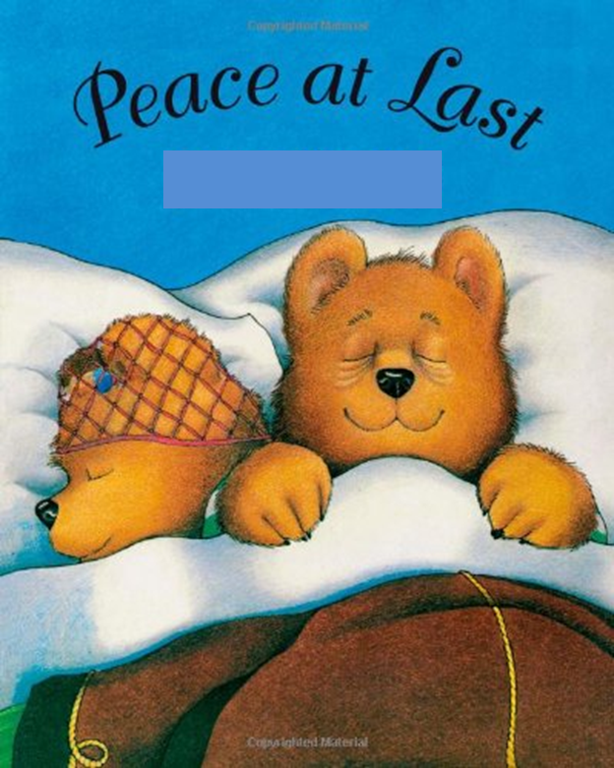 Draw a picture of Mrs Bear or Mr Bear or Baby Bear.

Handwriting – using your fingers follow the patterns then use a pencil to follow these patterns. Can you make your own pattern?

Songs and rhymes log on and learn:

* Miss Polly had a Dolly
* Jack and Jill Went up the Hill
* Five Little Ducks went swimming One Day

<https://www.bbc.co.uk/teach/school-radio/nursery-rhymes-a-to-z-index/z4ddgwx>

With someone in your family, learn some actions to go with these rhymes

Remember school website is: www.moorside.newcastle.sch.uk/website

If stuck email [Linda.hall@moorside.newcastle.sch.uk](mailto:Linda.hall@moorside.newcastle.sch.uk)