**Moorside Community Primary School**

Moorside Community Primary School

*Diary Dates – November 2017*

**Family Learning**

***Tuesday*** - 9.15-11.15 Story Sacks for parents/carers of Nursery and Reception classes.

***Wednesday***- 9.15 -11.15 Phonics Read Write Inc. for parents/carers of Reception classes.

***Thursday-*** 13.15-15.15 Family Language.

*Tuesday: Samba – Y6*

*Wednesday: Trumpets – Y4*

*Thursday: Swimming – Y3*

Important dates

Next week (commencing 13th November), we will be focussing on reading and also anti-bullying. The children will undertake many different activities in class to support these areas.

We are inviting parents and carers in to school **Tuesday, Wednesday and Thursday 8:50 – 9:30.** This is a great opportunity to spend time reading with your children and promoting the enjoyment of reading.



Important dates

School will be supporting Children in Need this year on **Friday 17th November.** The children are asked to wear something yellow or something with spots. Please note, pyjamas will not be allowed. We would ask that the children bring a silver coin to support this worthwhile cause.

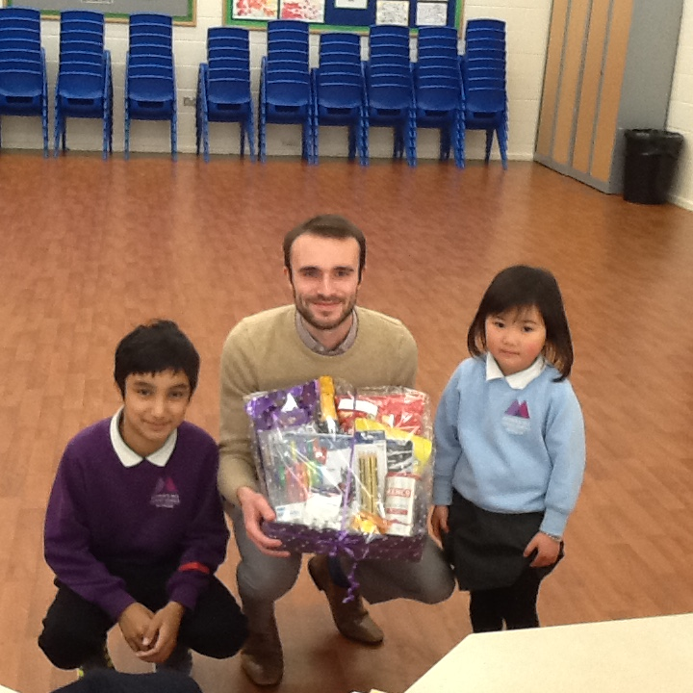

One of our main priorities is to improve attendance across the school. As part of this, all children who receive 100% attendance for each half term are placed into a raffle to win an exciting, delicious hamper. For autumn half term, Mahin and Michelle were the lucky winners. Well done to both of you! We hope you enjoy your hamper!

Well done class 1CS for getting 99.5% attendance!

**Week commencing: 30th October 2017**

**Stars of the Week!**

Each week the teachers from Reception to Year 6 classes will select a child that they believe has worked really hard that week, has carried out something special or been exceptionally kind to someone. We will then share this in assembly on a Monday with others and present them with a certificate to acknowledge their hard work. Then throughout the rest of the week they will lead their class in and around school.

This week’s stars are:

* **Amelia Akram (RC)** for communicating with her friends.
* **Lamar Garada (RW)** for excellent reading.
* **Ezra Adesina (1C)** for settling into our class so well.
* **Renad Ahmed (1CS)** for great listening and helping her friend..
* **Syed Ahmed** **(1L)** for a great drawing of the Angel of the North.
* **Jessica Wilkinson (2A)** for doing her best at maths and getting better every day.
* **Maria Rahman (2J)** for trying hard in her writing and improving every week.
* **Tina Xiao (3G)** for settling in brilliantly. Well done!
* **Marta Garcia Mesa (3R)** for adding and subtracting multiples of 100.
* **Ibrahim Ali (4L)** for great skills in P.E.
* **Andile Diabongana (4P)** for trying hard in all subjects.
* **Hamera Jhangir (5S)** for making an excellent start at understanding vocabulary from Oliver Twist.
* **Daniela Karchnakova (5W)**  for trying hard in our shared reading time.
* **Arshan Chowdhury (6B)** for considering how changes in formality can be used to convey character in a playscript.
* **Andreea Alexe** **(6R)** for making an effort to write independently.
* **Amber Smith (6W)** for consistently writing engaging text – whatever the genre.

Attendance w/c 30/10/2017:

|  |  |
| --- | --- |
| Class | Attendance |
| RC | 89.1% |
| RW | 93.6% |
| 1C | 94.0% |
| 1CS | 99.5% |
| 1L | 88.5% |
| 2A | 96.0% |
| 2J | 94.7% |
| 3G | 99.3% |
| 3R | 95.9% |
| 4L | 95.6% |
| 4P | 95.8% |
| 5S | 92.5% |
| 5W | 93.1% |
| 6B | 90.0% |
| 6R | 91.7% |
| 6W | 92.2% |