**Maths**

Area of a rectangle

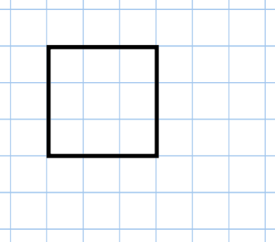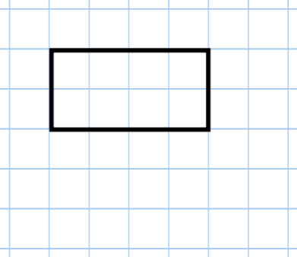

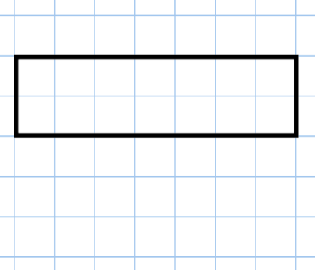

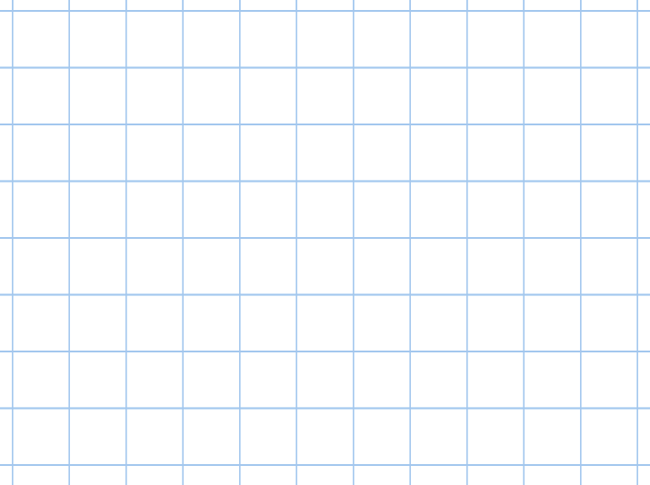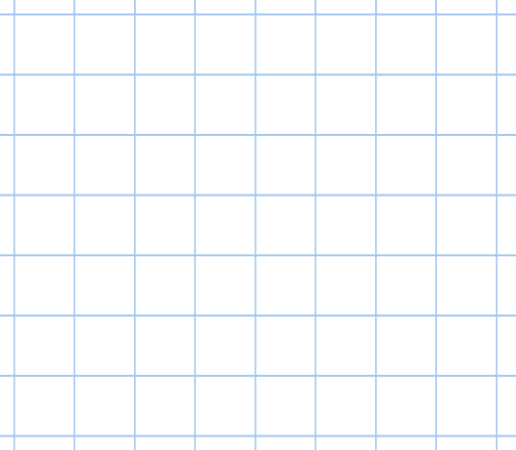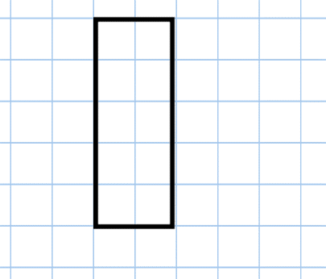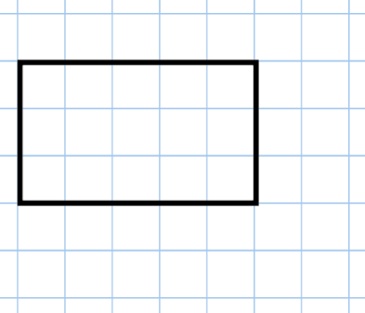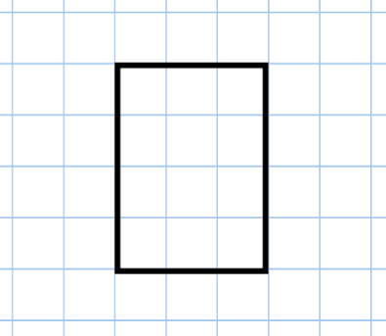

Draw a rectangle which has an area of 18cm2.

Draw a rectangle which has an area of 6cm2.

Area = _____cm2

Area = _____cm2

Area = _____cm2

Area = _____cm2

Area = _____cm2

Area = _____cm2