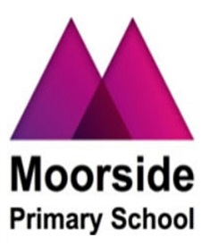  
  
  
  
  
  
  
  
  
  
  
  
  
  
  
  
  
  
  
  
  
  
  
  
  
  
  
  
  
  
  
  
  
  
  
  
  
  
  
  
  
  
  
  
  
  
  
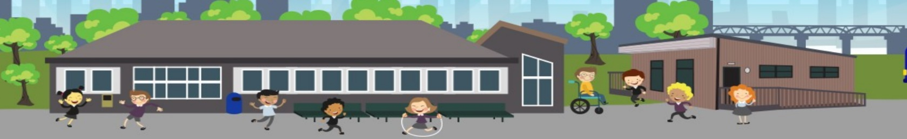

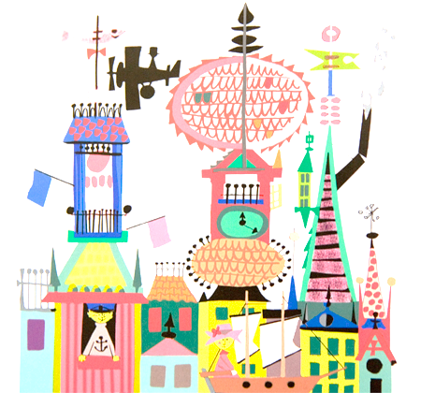

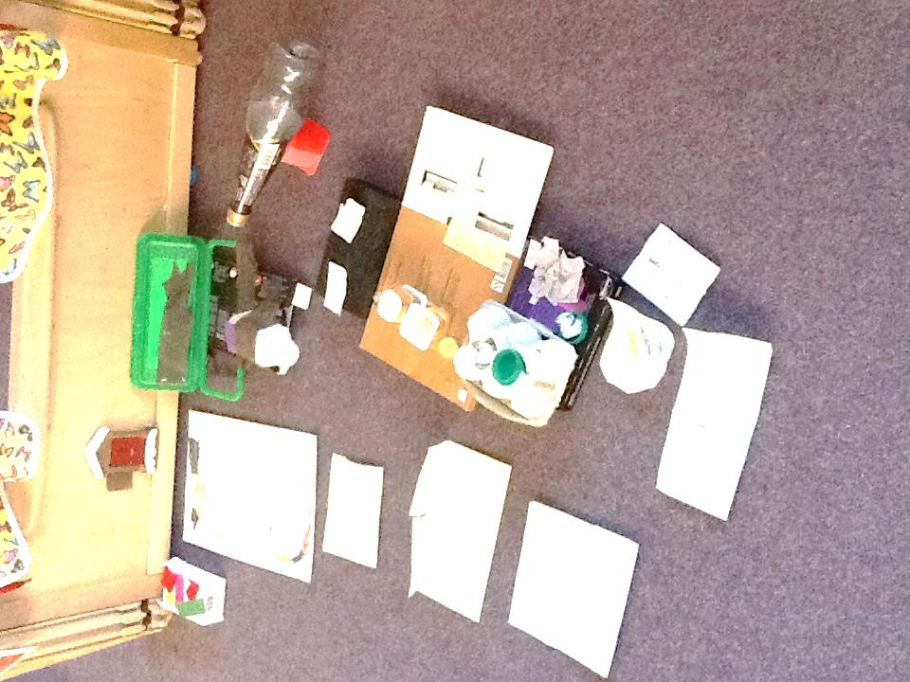

**Year 5**

This half term, Year 5 have been learning how to play the ukulele. They have been shown how to hold it correctly and which fingers are to touch the strings. They have also looked at different parts of the instrument and learnt how they create sound. They then investigated the different sounds that can be created through strumming. They are currently learning the different hand positions in order to play chords.

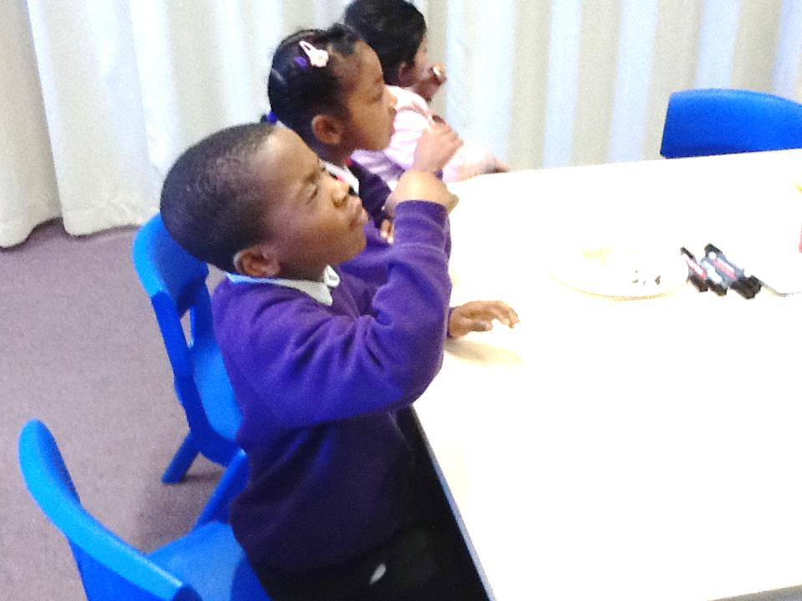

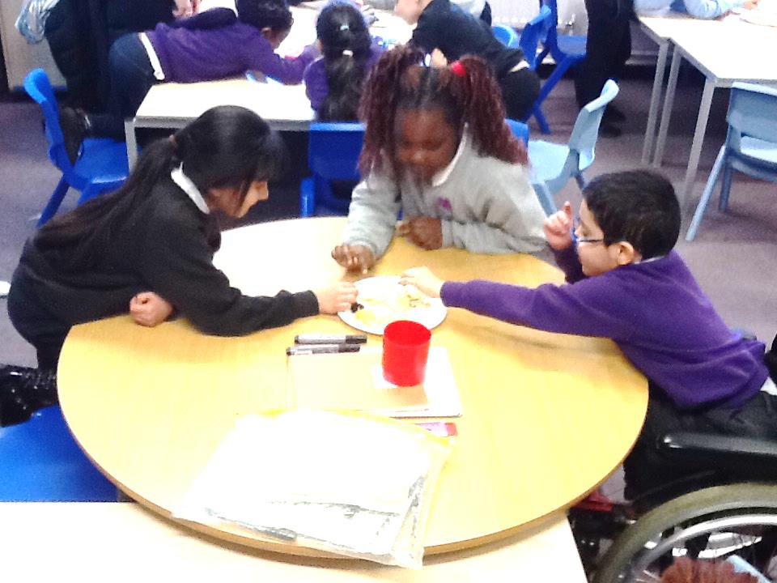

**Year 2**

Year 2 have experimented with the textures of food. They experienced rough, crinkled and dry textures and discussed how they felt in their mouths.

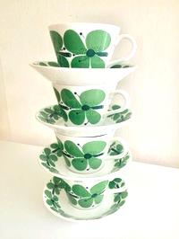

Can you name any chords played on the ukulele?

Tell a grown-up which texture you liked the most and why.

**Year 4:**

Year 4 have been learning about Scandinavia, looking at where in the world it is located, and the countries within it. They have also been looking at some of Stig Lindberg’s art, who is a Scandinavian designer.

**Challenge:**

**Which countries make up Scandinavia?**

**Reception :**

Reception have been learning all about the Elves and the Shoemaker. They were so excited to find that Elves have moved into their classrooms. They have been sending letters and making presents for the Elves.

**Challenge:**

**Can you retell the story of the Elves and the Shoe Maker to a grown-up?**

**Moorside Primary School**

**Newsletter**



**Dates for the diary:**

* **February Half Term** – School closed from Monday 18th to

Friday 22nd February 2019

* **Easter Holidays** – School closed from Monday 8th April to

Monday 22nd April 2019.

School reopens on Tuesday 23rd April.

* **Polling Day** – School closed on Thursday 2nd May 2019
* **Year 6 SATS Inspire** – Parents welcome on Tuesday 12th February

at 9:15am

* **Science Week** – This will be week commencing 25th February

information to follow.

Name some of the instruments you played in the Samba band.

**Nursery:**

Nursery have been reading the Owl Babies story this term and learning facts about owls such as where they live, what they hunt and what they look like. They have been retelling the story using props.   
Since our science focus is growing, we have been to the meadow to look at plants and trees.

**Challenge:**

**When do owls like to hunt for food?**





Explain to a grown-up what an artefact is.

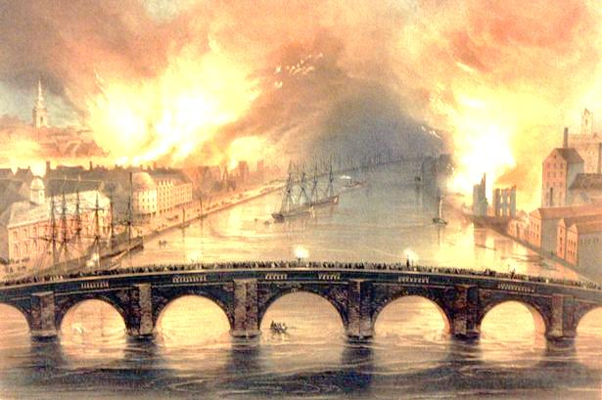

**Year 1:**

Year 1 went on an exciting trip to the Discovery Museum. They went there to learn about the events of The Great Fire of Newcastle and Gateshead. They acted out the events of the fire and then performed a puppet show. They found a painting that they had been looking at in school which showed this event.

**Year 3:**

InYear 3, the current Science topic is learning about animals. We have enjoyed learning about endoskeletons, exoskeletons and hydrostatic skeletons. In Art, they have looked at the work of Antony Gormley, who designed the Angel of the North and whose work is inspired by the human body. They enjoyed using lego to recreate some of his structures.

**Challenge:**

**How many bones are in the human body?**

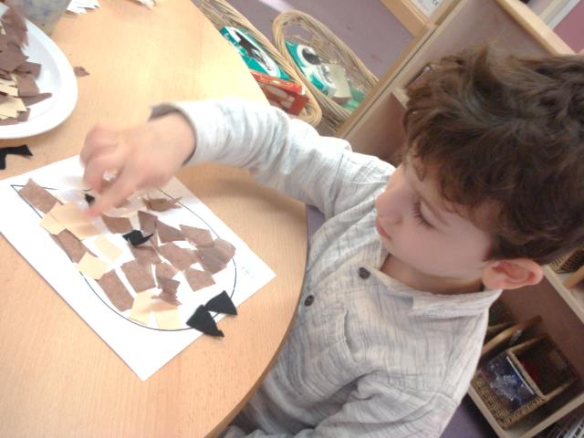

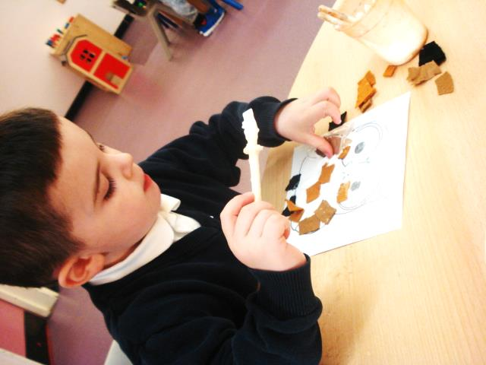

**Year 6:**

Year 6 have learnt about Samba music in their music lessons. They have learnt terms related to Samba music such as repanique as well as learning how to play different sections of a piece of music which then all come together in one final foot-tapping piece. Children also learnt how to add dance moves to make their finished piece more interesting.