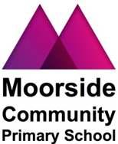

Proposed membership of the West End Schools’ Trust (WEST)

Instead of writing or emailing your response, we are happy to accept this questionnaire duly completed. Please return it to the school office. The Public consultation period is from the 22nd May 2018 to 19th June 2018 at noon.

Parent / Staff/ Governor / Other (please specify …………………..………………..

1. What are your views about the proposals for Moorside community Primary School to become Foundation School and join the West End Schools’ Trust

Please tick the appropriate box
I am enthusiastic about the proposals

I support the proposal

I am not sure and would like more information about ……
I do not support the proposal (because ….

2. Do you have any other comments, concerns or suggestions that you think we should consider before we make a decision about the proposals?

Thank you for your help.

