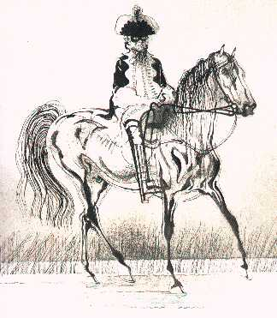**Identifying adverbials**

Read each sentence below from the poem ‘The Highway Man’. Can you spot the adverbials?

Sort them into a table with these headings:

* How the action was done or event occurred.
* Where it happened or occurred.
* When it happened or occurred

|  |  |  |
| --- | --- | --- |
| How the action was done or event occurred | Where it happened or occurred | When it happened or occurred |
|  |  |  |

HINT – underline the main clause to help you spot the adverbials – the main clause will not be part of the adverbials. The first one is underlined as an example.

1. Under the moonlit, cloud-swept sky, the highwayman came galloping across the moor.
2. Silhouettes of trees flailed their bent arms in the depths of the wood.
3. They cast long shadows awkwardly on the rain-soaked ground.
4. Owls and bats crossed the woods well after midnight.
5. Without a sound, the highwayman’s horse padded across the low dark undergrowth.
6. She made her way through the earthy, damp ferns.
7. The highwayman’s heart filled him with longing for his girl.
8. At long last, the hooves of his proud, sleek mare clattered like a guilty secret on the harsh grey cobblestones.

Now rewrite some of these sentences changing the meaning by changing the adverbials.

Check your sentences for commas which make the meaning clear.