INSPIRE, CHALLENGE, EXCEL
Moorside Community Primary School
Beaconsfield Street
Newcastle upon Tyne
NE4 5AW

admin@moorside.newcastle.sch.uk

Executive Headteacher: Mr P Wilkins
Head of School: Ms L Hall
Telephone 0191 2720239

17 July 2017

Dear Parents & Carers,
Important news for parents and carers of Moorside Community Primary School.
On behalf of the Governing Body of The Federation of Arthur’s Hill Primary Schools, I am writing to inform you that the formal link between Moorside Community Primary School and Westgate Hill Primary School is anticipated to change significantly at the end of this 16/17 academic year.
At present, both federation schools are Local Authority maintained and operate under the direction of one single and overarching governing body. However, it is now anticipated that Westgate Hill will change status and become an Academy, with effect from 1st September 2017, joining the Laidlaw Schools’ Trust. Moorside, on the other hand, will remain under local authority control and will form its own governing body with effect from the same date.
In practice, parents, children and the wider school community will see no difference to the quality of educational service provided by Moorside going forward into the new school year in September.
This is the end of an era for Moorside and Westgate Hill and many of you with close associations with both schools will have mixed feelings about the end of the ‘federation’. This formal relationship has brought many benefits and opportunities over recent years. Although the formal link between the two schools is coming to an end, governors and school leaders are committed to ensuring ongoing partnership work continues into the future. After all, the two schools are geographically very close and will continue to have lots in common.
Distributed with this letter are nomination forms for any current Moorside parent to put their names forward for the re-constituted Governing Body. At this point nominations are very welcome from any parents who want to get involved. In September a ‘parent governor’ election will take place if required.
Yours Sincerely,
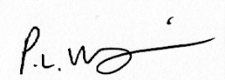 Executive Head
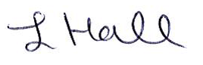Head of School

