Moorside Community Primary School
Newsletter
Newsletter
Dates for your Diary
Half Term Holiday: Monday 12th February to Friday 16th February
Polling Day: Thursday 3rd May (school closed)
INSET Day: Friday 15th June (school closed)

Moorside News by Amber Smith (Year 6)

Newcastle Foundation
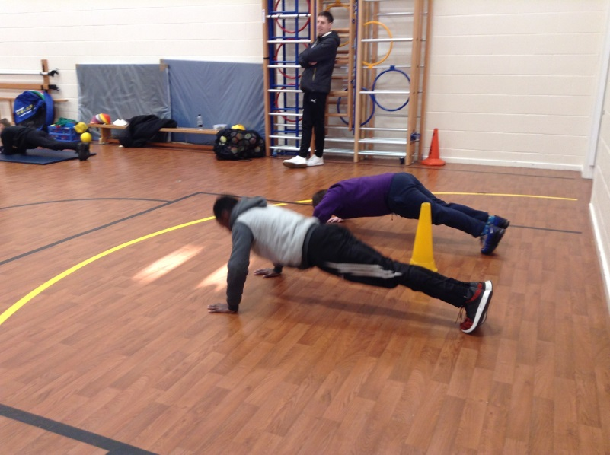
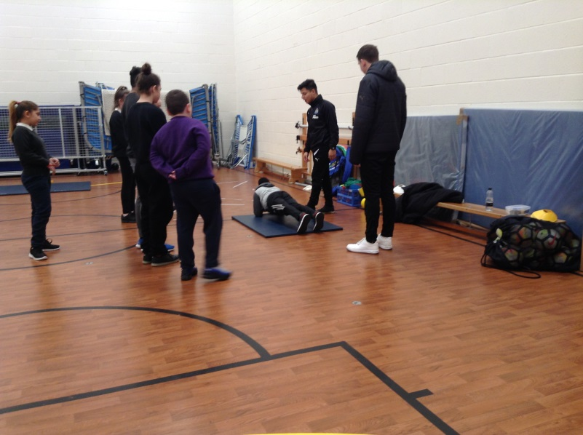
Newcastle Foundation have been coming in to school to lead clubs and P.E lessons from Reception to year 6.
“They’ve been teaching us about movement and basic skills.” Arshan Chowdhury.
They lead the Friday sports club training children to be fitness leaders.

A Child Friendly Policy
We have decided to create child friendly policies for the children here at Moorside. The behaviour policy has already been written by the Year 6 School Council and the School Council team are now collecting ideas for the anti-bullying policy. As a school we have been working hard on preventing bullying and the policies will soon be up on the website:
http://www.moorside.newcastle.sch.uk/website

Kindness Stickers
Since the updated version of the Code of Conduct has been released, the school is moving forward to encourage kindness and stop bullying. Teachers will hand out stickers for good behaviour and acts of kindness. We will add up the stickers each pupil has received. Whoever gets the most from their class, will go in a hat to win a prize!

Well done to 4P for achieving 95.6% attendance!

w/c 22nd January 2017

Stars of the Week!

w/c 29th January 2018
Attendance w/c 15/01/2018:

Class | Attendance
RC | 95.2%
RL | 88.6%
1C | 91.0%
1CS | 95.0%
2A | 94.5%
2J | 91.3%
3G | 93.7%
3F | 89.3%
4W | 91.9%
4P | 95.6%
5S | 90.0%
5W | 95.4%
6B | 90.4%
6R | 92.0%

Each week the teachers from Reception to Year 6 classes will select a child that they believe has worked really hard that week, has carried out something special or been exceptionally kind to someone. We will then share this in assembly on a Monday with others and present them with a certificate to acknowledge their hard work. Then throughout the rest of the week they will lead their class in and around school.

This week’s stars are:
- Hafsa Ali for trying hard to learn how to write her name .
- Serkeft Ahmed for a good try at writing words.
- Lamar Garada for a great retelling of “The Elves and the Shoemaker”.
- Suhail Ahmed for great writing.
- The Whole Class (1C) for an amazing trip to the Discovery Museum.
- Ashleig h Todd for a great stained glass window picture.
- Mahbub Ahmed for excellent explanations of our vocabulary during our English lessons.
- Derya Gulli for excellent work in maths.
- Binar Sadiq for lovely sentences and use of punctuation.
- Reemaz Mohammed for excellent use of the atlas.
- Aryan Ahmed for excellent effort in maths.
- Arshan Chowdhury for asking interesting questions in history to extend his knowledge.
- Adiy Hussain for writing an excellent character description.
- Marek Milo for excellent multiplication of 2 digit numbers.
- Owen Thomson for his work in guided reading and group discussions.

Well done to 4P for achieving 99.2% attendance!

Stars of the Week!

Attendance w/c 22/01/2018:

Class | Attendance
RC | 95.6%
RL | 90.0%
1C | 90.0%
1CS | 95.3%
2A | 94.5%
2J | 92.3%
3G | 97.3%
3F | 94.3%
4W | 90.0%
4P | 99.2%
5S | 95.2%
5W | 98.9%
6B | 95.6%
6R | 92.6%

- Oriana Lomami for fantastic reading and bringing her folder in regularly.
- Amy Thomson for being a good friend to our new child.
- Dani Tocila for settling into reception and making new friends.
- Nikolina Marinkovic for being a fantastic role model.
- Renad Ahmed for being a great role model and working hard.
- Mohammed Saif for making excellent improvements with his handwriting.
- Mai Adabashi for excellent work and perseverance in maths.
- Tanisa Hussain for swimming on her back without a float.
- Maria Karchnakova for better use of capital letters.
- Motasem Lamah for trying hard in all subjects.
- Shaona Shohid Eema for always giving her best effort with a smile.
- Hira Azam for her fantastic effort and achievement using a formal method of division.
- Zahid Rustam for her great contributions in our RE lessons.
- Nafi Al-Nima for being welcoming to new adults and children.
- Angel Christian for great division with decimals.

