Class top reads
Playgroup | 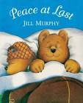  Peace at last  (Jill Murphy)
Nursery | Goldilocks and the three bears.  (Robert Southey)
RK | Detective dog well.  (Julia Donaldson)
RA | 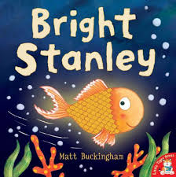  Bright Stanley and the cave monster  (Matt Buckingham)
1C | Willbee the bumblebee  (Craig Smith)
1T | 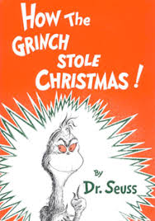  How the Grinch stole Christmas  (Dr.Suess)
2H | Find me a tiger  (Lynley Dodd)
2W | Island of horror  (Patrick Burston)
3B | 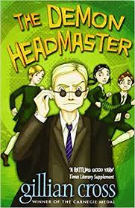  The Demon headmaster (Gillian Cross)
3L | 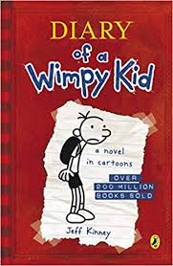  Diary of a wimpy kid  (Jeff Kinney)
4C | 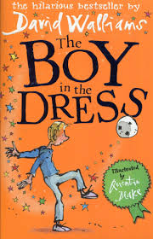  The Boy in the dress (David Walliams)
4LJ | 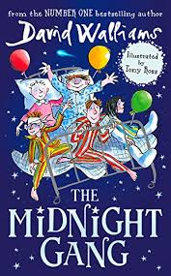  The Midnight Gang  (David Walliams)
5W | 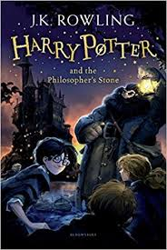  Harry Potter and the philosophers stone  (J.K Rowling)
5RH | Oliver Twist  (Charles Dickens)
6K | 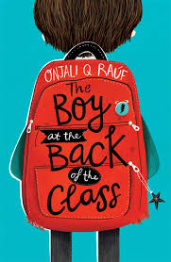  The Boy at the back of the class.  (Onjali Q. Raúf)
6D | Holes  (Louis Sacher)
6C | Black cats and Butlers. (Janine Beacham)

