

Moorside Community Primary School

Newsletter

Newsletter

**Playing in the Snow 18.01.2018**

The children had a great time yesterday lunchtime playing in the snow here at Moorside. Many snowmen appeared and there was a lot of excitement especially among the children who had seen snow for the first time!

“We all had great fun”.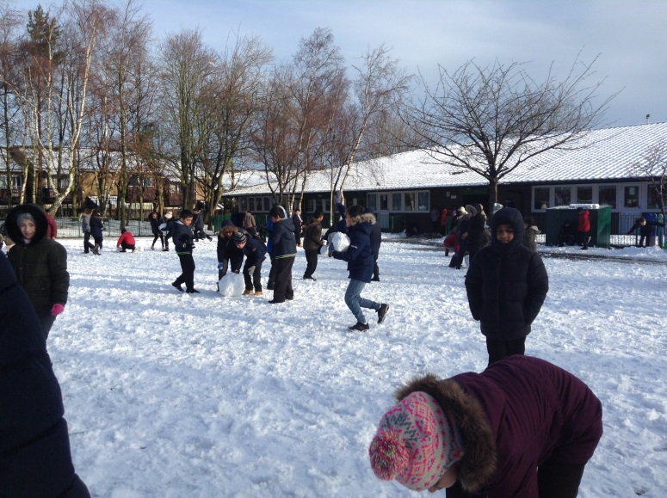

**Year 6 Begin Work**

This week, Year 6 children have begun their new jobs. Back in November, they all wrote job applications to Mrs Hall. In the final week before Christmas, they received their feedback.

Mrs Hall said “**The standard of applications I received was exceedingly high. I was very impressed at the willingness of the children to take on extra responsibility. Well done year 6!**”

Some of the jobs include:

* Helping Key Stage 1 children play at lunchtime
* Helping out with the children in Early Years at lunchtime
* Being playtime buddies
* Looking after the computers, and
* Running clubs such as music, art and fitness.

by Amber Smith (Year 6)

**Brand New Books**

As one of the school’s main focuses is reading, we have decided to invest in a range of new books. The School Council asked the children what their favourite books are and some may soon appear on the shelves.

by Amber Smith and Maymunah Hoque (Year 6)



**Code of Conduct**

We have re-issued our Codes of Conduct detailing the conduct expected of children attending our school to ensure a happy school where everyone can thrive to become caring and active citizens.

Every child (from Reception to Year 6) will be asked to read and then sign this code of conduct.





Well done to **4P** for achieving **93.8%** attendance!

**w/c 8th January 2017**

**Stars of the Week!**

**w/c 15th January 2018**

Attendance w/c 18/12/2017:

|  |  |
| --- | --- |
| Class | Attendance |
| RC | 87.1% |
| RW | 93.2% |
| 1C | 83.0% |
| 1CS | 83.1% |
| 2A | 91.7% |
| 2J | 84.0% |
| 3G | 90.3% |
| 3R | 86.3% |
| 4L | 90.0% |
| 4P | 93.8% |
| 5S | 90.4% |
| 5W | 92.1% |
| 6B | 90.0% |
| 6R | 92.3% |

Each week the teachers from Reception to Year 6 classes will select a child that they believe has worked really hard that week, has carried out something special or been exceptionally kind to someone. We will then share this in assembly on a Monday with others and present them with a certificate to acknowledge their hard work. Then throughout the rest of the week they will lead their class in and around school.

**This week’s stars are:**

* **Dina Musa** for listening carefully and trying so hard with her learning .
* Leonardo Mihajlovic for trying so hard to listen to the teachers and follow instructions.
* **Keeley-Rose Bulmer** for trying so hard to listen to the teachers.
* **Yaqub Al-Nima** for trying so hard with his learning.
* **Maddison Arrowsmith** for always being so happy and pleasant towards others.
* **Danny Ruan**  for working so hard and listening carefully.
* **Naseer Ali** for always being pleasant and polite to others.
* **Ayden Rowlands** for trying hard and listening carefully to others.
* **Sophie Cheel** for being so brave and joining in the assembly.
* **Kelsey Thomson** for always being caring, helpful and kind towards others.
* **Sara-Daiana Omar** for always being so pleasant and helpful.
* **Ben Duff** for trying and working so hard.
* **Arshan Chowdhury** for always being a positive role model in all that he does.
* **Tomas Pulko** for trying so hard and listening carefully to the teachers.

Well done to **4P** for achieving 95.1**%** attendance!

**Stars of the Week!**

Attendance w/c 08/01/2018:

|  |  |
| --- | --- |
| Class | Attendance |
| RC | 90.5% |
| RL | 88.4% |
| 1C | 88.6% |
| 1CS | 89.3% |
| 2A | 94.1% |
| 2J | 83.7% |
| 3G | 90.0% |
| 3F | 87.0% |
| 4W | 91.4% |
| 4P | 95.1% |
| 5S | 85.2% |
| 5W | 91.7% |
| 6B | 84.8% |
| 6R | 84.6% |

* **Hafsa Ali** for trying hard in group time.
* **Miley Black** for blending sounds to read words.
* **Jordan Parry** for fantastic effort with his reading.
* **Lee Robinson** for trying hard with his writing.
* **Ted Chaffey** for great participation in lessons and sharing great vocabulary.
* **Lexiann Wears** for settling in very well to her class and trying very hard in all of her work.
* **Jessica Black** for swimming on her own with just one float.
* **Jessica Ogle** for using the conjunction ‘and’ in her writing.
* **Mehthaab Kazi** for using great sentence structure in her writing.
* **Mahfus Ahmed** for trying so hard in his maths.
* **Robert Jarka** for a great learning attitude in our first week back.
* **Mahira Akhter** for excellent work in mental maths, especially multiplying 3 numbers together.
* **Shoaib Ashfaq** for a much improved attitude to learning.
* **Asad Jamil** for offering to support a new class member.