Year 2 (Tuesday 9.2.21)
Exercise: Stretch your whole body by trying a ‘Mexican wave’. Lower your arms and bend your knees, then wave your arms upward and stretch up high. Then try this by sweeping your arms from side to side, how far can you stretch? Repeat until your body feels stretchy and warm. Then run on the spot for 1 minute.
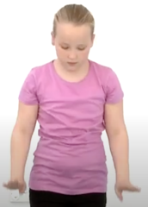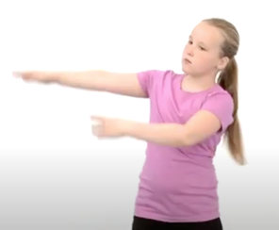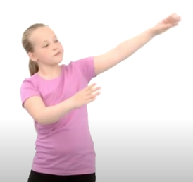
English Learning intention: To write a story.

Read the PowerPoint and then continue to write your witch story, this time writing the end of the story. Can you change the ending to make it more interesting? Edit your story map then say your new sentences out loud before writing them.

Alternative 1: Use the PowerPoint and your story map from last week to help you to write the ending of the story.
Alternative 2: Use the PowerPoint to rehearse the ending of your story. Can you say the sentence out loud to help you? Then you could try writing the sentence.

Spelling: would who whole

Handwriting: practise ‘o-e’ using the PowerPoint. Alternative 1: practise ‘oo’ using the PowerPoint. Alternative 2: practise ‘t’ using the PowerPoint.

Reading
Grey and blue- Read ‘Silly Games’ again using yesterday’s PowerPoint or Oxford Owl. Retell the story using the worksheet. Then try the questions.
Orange and yellow- Find the words containing ‘ir’ in the letter on your sheet. How many can you find? Then try to write as many ‘ir’ words as you can think of.
Alternative reading
Red and green- On the worksheet, read the words containing the ‘th’ special friend. Then cover the words up and write them with their pictures.
Purple and pink- On the worksheet, read the words containing the ‘ow’ special friend. Then cover the words up and spell them.

Maths Learning intention: To identify and describe the properties of 3D shapes.

Use the PowerPoint to learn about vertices on 3D shapes. Then apply this knowledge to complete the worksheet.

Alternative 1: Use the PowerPoint to consolidate the names of 3D shapes. Complete the worksheet to identify the odd shape and match the labels to the shapes.
Alternative 2: Use your knowledge of recognising and naming 3D shapes to complete the worksheet. You might want to look at yesterday’s PowerPoint again to remind you of the shape names.
PSHE Learning intention: To develop knowledge of e-safety.
Listen to or read the PowerPoint about staying safe online. Talk to an adult about what you have learnt. You could make a list of your own internet safety rules.

Remember school website is: http://www.moorside.newcastle.sch.uk/website
If stuck or want to send completed work then email linda.hall@moorside.newcastle.sch.uk

