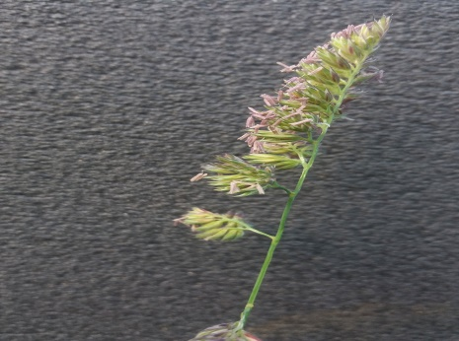
Week fourteen

Grasses, Butterflies and Bees
Did you know that some butterflies lay their eggs on grasses and their caterpillars eat grass leaves?

In the Orchard in Nuns Moor Park there are Meadow Brown and Speckled Wood butterflies whose caterpillars feed on grasses Cocksfoot and Yorkshire Fog.
Some Honey Bees collect the pollen from Cocksfoot grass and some Bumble Bees live in the tussocks made by Cocksfoot.

This is the best time of year to identify grasses.
Yorkshire Fog looks very different as it grows, all the grasses in the picture are Yorkshire Fog!

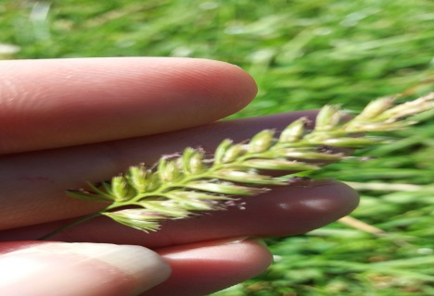
Crested Dogs Tail is found on The Moor. The stem looks a bit like a dog's tail.

https://www.woodlandtrust.org.uk/trees-woods-and-wildlife/plants/grasses-and-sedges/cocksfoot-grass/

Cocksfoot Grass (Dactylis glomerata) - Woodland Trust
What does cocksfoot grass look like? Cocksfoot grass is perennial and commonly grows in dense tussocks which can be 20–140cm tall. Its key characteristic is a flattened stem base which separates this grass from others.

www.woodlandtrust.org.uk

