3.

2 rows of 10



4.

6 rows of 5



6.

4 rows of 10

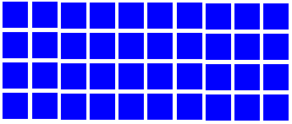

5.

5 rows of 2

**Example:**

2 rows of 5

|  |  |  |  |  |  |  |  |
| --- | --- | --- | --- | --- | --- | --- | --- |
|  |  |  |  |  |  |  |  |
|  | **5** | **x** | **2** | **=** | **1** | **0** |  |
|  |  |  |  |  |  |  |  |

8.

3 rows of 10

|  |  |  |  |  |  |  |  |  |  |
| --- | --- | --- | --- | --- | --- | --- | --- | --- | --- |
|  |  |  |  |  |  |  |  |  |  |
|  |  |  |  |  |  |  |  |  |  |
|  |  |  |  |  |  |  |  |  |  |

9.

10.

7.

2.

4 rows of 5

|  |  |  |  |  |
| --- | --- | --- | --- | --- |
|  |  |  |  |  |
|  |  |  |  |  |
|  |  |  |  |  |
|  |  |  |  |  |

1.

3 rows of 2

3 rows of 5



7 rows of 5

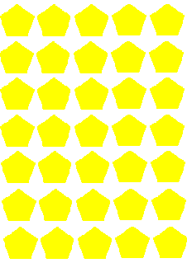

4 rows of 2

