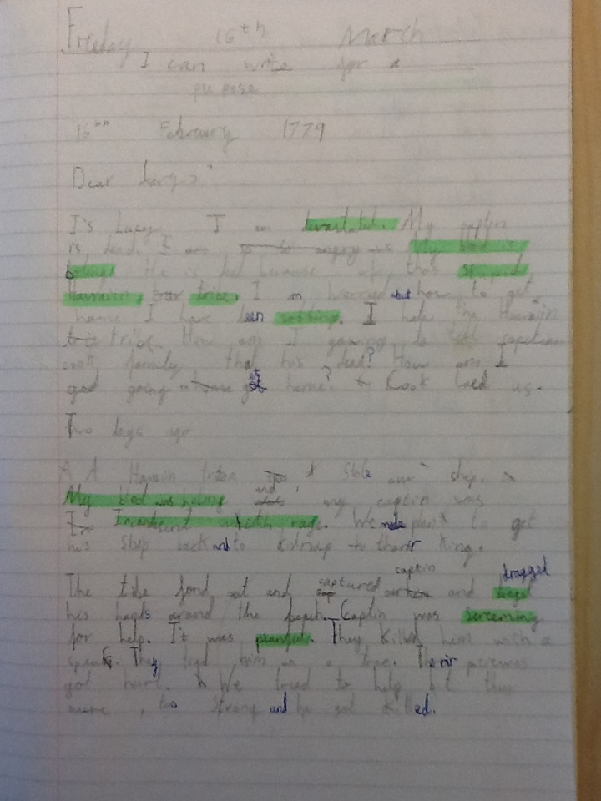

Mai wrote a fantastic diary entry using lots of emotive language. Miss Johnson said it was one of the best pieces of work she had ever read. She made Miss Johnson, Miss Rowe and Ms Hall very proud! Well done Mai, keep the great work up.

